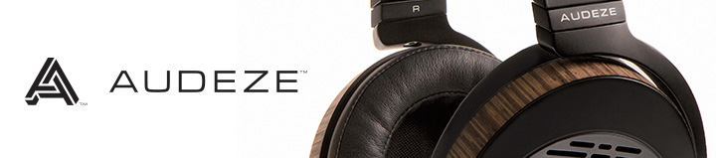
Visit us at THE Show Newport Headphonium Booth 78

Costa Mesa, CA | May 26th, 2015 | Audeze, maker of award-winning planar magnetic headphones, is happy to attend T.H.E. Show Newport, May 29th – 31st, in the Headphonium, Booth 78. You’ll be able to audition the EL-8 open and closed-back versions, LCD headphones, and the Deckard DAC/Headphone Amp.

EL-8s Available at Apple Online Store
The EL-8 closed-back is available now at the Apple Online, the open-backs available there soon. These include an Apple cable with inline microphone and 3-button controls that will also work as standard audio cables. Some functions will work with Android (especially version 4.4.4) and Blackberry. Both audio cables are included, Apple and standard, and there’s no change to the $699 retail pricing.
Additional Cables Available
- Balanced cable with 2 x 3.5mm stereo connectors for PONO and Sony PHA-3, $49 USA retail.
- Balanced cable with 2.5mm connectors for Astell & Kern - $49 USA retail.
Prices subject to change

Digital Trends gave the EL-8s a Top Tech CES 2015 Award plus an Editor’s Choice Award in their full review. Here are a few choice comments:
“There’s an effortless, almost sumptuous way the EL-8s approach their revelation of detail … The EL-8 proved almost startling in their clarity, luminous and pristine, without ever becoming abrasive and especially impressive in the handling of higher instruments and percussive effects.”
Visit the Audeze team at the Headphonium booth 78 at THE Show Newport
Follow us on social media

Audeze | Costa Mesa, CA 92626
Tel 714.581.8010 | Fax 702.823.0333
info@audeze.com | www.audeze.com

