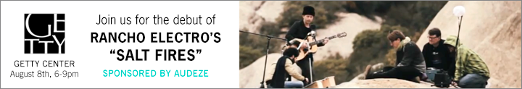
Join Audeze for the debut of “Salt Fires”
Created by Mikael Jorgensen and Alexander Rosson at the Getty Center
Free Admission 6 to 9pm in the Museum Courtyard

Costa Mesa CA | August 8th, 2014 | Audeze, maker of award-winning planar magnetic headphones, components and accessories, invites you to join them at the Getty Center, Friday August 8th, 6 to 9pm, in the Museum Courtyard, for a stunning evening of sight and sound sponsored by Audeze CEO Alex Rosson and Wilco’s Grammy-winning Mikael Jorgensen.

They’ll debut the first installment of the Rancho Electro Sessions titled "Salt Fires" featuring a collaboration between Mikael Jorgensen and Graph Rabbit. It was all captured live and recorded binaurally with Audeze’s proprietary equipment to bring you exactly what the artists intended with the environment as part of the performance.

Friday Flights at the Getty Center Information
1200 Getty Center Drive, Los Angeles, CA.

We look forward to seeing you there.
Contact Alex Rosson alex@audeze.com

About Audeze
Audeze LLC is a California-based high-end audio manufacturer delivering the most accurate sound reproduction available today. Audeze products are engineered with the latest innovations in materials science and technology matched with precision craftsmanship. Audeze’s commitment to research and development is reflected in every facet of our made-in-the-USA products.

Audeze | Costa Mesa, CA 92626| Tel: (714) 581-8010 | Fax: 702.823.0333
info@audeze.com | http://www.audeze.com

Jonathan Scull | Scull Communications
Tel 212 807.0519 |Cell 646.369.3340 | Skype J10Scull
jscull@scullcommunications.com | www.scullcommunications.com
www.scullcommunications.com/pressresources.html

