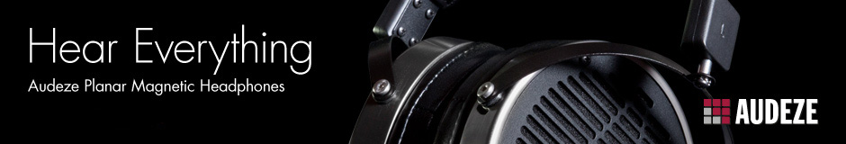
Audeze Partners with Chris Milk in Historic Virtual Reality Breakthrough at the Sundance Film Festival
Fountain Valley CA | January 20th, 2014 | Famed Audio Video designer Chris Milk debuts his groundbreaking Virtual Reality system at the Sundance Film Festival with audio partner Audeze. The ongoing Festival runs through January 26th.
The revolutionary virtual reality system, the first of its kind, opens the floodgates for VR technology that will forever change the way people experience music, film and live performance. The project was realized in conjunction with Oculus VR, 3d-io and automobile manufacturer Lincoln.
Alex Rosson, Audeze CEO, said: “We’re honored to provide the headphones that are part of this breathtaking virtual reality experience. Our participation reaffirms Audeze's commitment to dissolving the barrier between performer and audience by advancing the way art and media are perceived by the user."
Oculus Rift’s Virtual Reality system makes it possible to be onstage with Beck, immersed in exciting sound and vision, making it easy to suspend disbelief and be one with the music. You can choose to leave the stage and roam around the audience… VR technology radically transforms the concert experience.
Milk captured the reimagined 1977 David Bowie song “Sound and Vision” using newly-patented technologies like full spherical image capture and 360-degree binaural/multi-aural audio recording. Reengineered for a virtual reality platform, the user can experience the first live-action film for the Oculus Rift VR headset as never before.
About Chris Milk
Chris Milk is an artist, director, and photographer who has created music videos for Kanye West, Arcade Fire, Johnny Cash, Norah Jones, Jack White, U2, Gnarls Barkley, Green Day, and many more. Known for his artistically and technologically innovative approach to cross-media storytelling, Milk’s acclaimed interactive projects include The Johnny Cash Project and Wilderness Downtown with Arcade Fire. His interactive installation artworks have been shown around the world including New York City's MoMA and London's Tate Modern.

About Audeze
Audeze LLC is a California-based high-end audio manufacturer delivering the most accurate sound reproduction available today. Audeze products are engineered with the latest innovations in materials science and technology matched with precision craftsmanship. Audeze’s commitment to research and development is reflected in every facet of our made-in-the-USA products.
Audeze | Fountain Valley, CA 92708 | Tel: 657.464.7029 | Fax: 702.823.0333
info@audeze.com | http://www.audeze.com

