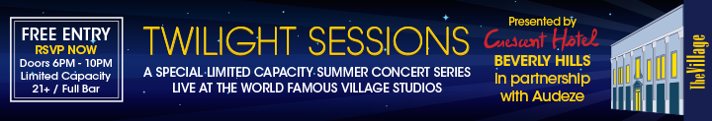
Audeze Sponsors Third of Four Twilight Sessions at the Famous Village Studios
Saturday September 13th, 6-to-10pm
Costa Mesa CA | September 11th, 2014 | Audeze, maker of award-winning planar magnetic headphones, components and accessories is proud to sponsor the third of four celebrations of music in association with The Village Studio and the Crescent Hotel Beverly Hills. Discover the next generation of artists in this legendary studio brimming with history.
The third of these limited-capacity events this Saturday, September 13th, features The Reverend Shawn Amos, the Bart Davenport Blue Band, Jerome Holloway, and a Special Guest Artist.
Email RSVP@villagestudios.com and experience these great bands in person. Hope to see you there!
Click to learn more about the LCD-X, the LCD-XC, the LCD-3 , and the LCD-2. Download the Online Press Kit for specifications and photos.
About Audeze
Audeze LLC is a California-based high-end audio manufacturer delivering the most accurate sound reproduction available today. Audeze products are engineered with the latest innovations in materials science and technology matched with precision craftsmanship. Audeze’s commitment to research and development is reflected in every facet of our made-in-the-USA products.
Audeze | Costa Mesa, CA 92626| Tel: (714) 581-8010 | Fax: 702.823.0333
info@audeze.com | http://www.audeze.com
Jonathan Scull | Scull Communications
Tel 212 807.0519 |Cell 646.369.3340
Skype J10Scull
jscull@scullcommunications.com | www.scullcommunications.com
www.scullcommunications.com/pressresources.html
Click here to unsubscribe.

