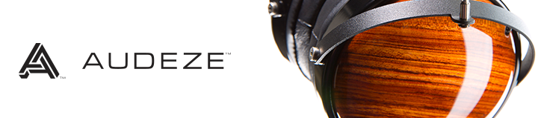
Visit Team Audeze at RMAF CanJam
Marriott Tech Center Friday October 10th - 12th
Costa Mesa CA | October 6th, 2014 | Audeze, maker of award-winning planar magnetic headphones is looking forward to participating in the 2014 Rocky Mountain Audio Fest CanJam, October 10th - 12th.
In other news, producer and mix engineer Ken Andrews is famous for his work on albums for Paramore, Beck, Nine Inch Nails and M83 and he has a lot to say about the LCD-X.

"Audeze headphones have transformed the way I mix. I can now do 80 to 90% of a mix on headphones, which is crazy to me, since every mix I have ever done on headphones prior to using Audeze has always suffered from the basic problems of headphone mixing. Audeze’s products don’t sound like headphones. They sound like really, really expensive studio monitors that you wear on your head! Being able to do professional level mixing on a laptop with the LCD-X is seriously mind blowing.”

Ken won a blind shoot-out against some of the biggest names in the mixing world. His prize: the plum job of mixing Paramore’s acclaimed #1 Billboard album. Look for an exclusive interview with Ken and Audeze CEO Alex Rosson.

Join Audeze at the Rocky Mountain Audio Fest
Marriott Tech Center Room 525
Friday October 10th - 12th
4900 S Syracuse St., Denver, CO 80237
Click to learn more about the LCD-3, LCD-XC, LCD-X, and LCD-2.
Visit the Online Press Kit for images and other resources.
About Audeze
Audeze LLC is a California-based high-end audio manufacturer delivering the most accurate sound reproduction available today. Audeze products are engineered with the latest innovations in materials science and technology matched with precision craftsmanship. Audeze’s commitment to research and development is reflected in every facet of our made-in-the-USA products.
Audeze | Costa Mesa, CA 92626 | Tel 714. 581.8010 | Fax 702.823.0333
info@audeze.com | http://www.audeze.com

