


The C7R Receiver

A DAC Integrated Amp with Tuner!

Amp Section Based on REF150 • Includes Phono Section

Why choose different components for your music downloads, computer, CD player, tuner, turntables, cable/satellite box or game consoles? Keep things simple with Bel Canto's compact, powerful C7R Receiver! It’s loaded with inputs -- two 24/192 SPDIF, two 24/192 TOSLINK, and one 24/96 USB, MM Phono and Analog Line Level inputs! Outputs are WBT NEXTGEN Speaker Connectors plus RCA Line Out and a Headphone Output.

The C7R is a fine-sounding, amazingly cool-running, high-output, low-power-usage complete analog and digital media center. It DAC features very low jitter allied with a high-isolation, low-noise power supply. Connect your computer, CD player, turntable, cable box or game console and you’re in total system control.
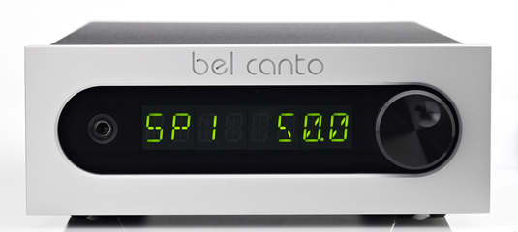
The REF150S-based power supply includes the REF-series filter board and like all Bel Canto components it runs so cool it can be placed in a wide variety of locations. Add a Bel Canto CD3t Transport and you’ve got an entire system in two high-performance half-width cases -- just add speakers!

The 24-bit digital volume control is completely transparent and accurate throughout the volume range. Advanced engineering details abound; 0.1% audio grade resistors, class-A output control circuitry, and low-noise power supply components. The heavy-gauge all-steel chassis design prevents mechanical resonance from compromising the audio signal. The stereo amplifier section is based on an elegant switching output stage that eliminates thermal distortion caused by changes in operating temperature.

The Wall Street Journal raves: “For bookshelf audiophiles who like their separate components down to the individual power supply, Bel Canto's full range of modular matching half-size power amps, CD players, FM tuners and digital-to-analog converters (for your PC music) is a dream come true. Though they're about as small as '80s-era microsystems, these handmade-in-Minneapolis stackables deliver enough sound and power for speakers 10 times their size.”

Bel Canto Design, Ltd. • Minneapolis • MN • USA www.belcantodesign.com
C7R Specifications
Amplifier Section
Power Output 1% THD |  | 120W @ 4 ohms, 60W @ 8 ohms per channel
Minimum Load |  | 3 ohms per channel
Peak Output Current |  | 30 amperes
Frequency Response |  | +/-3 dB 1.5Hz-90kHz, 4 ohm load
THD+N |  | 0.003% 1W, 1kHz, 4 ohms
IMD (CCIF) |  | 0.0003%, 1W, 14:15kHz, 4 ohms
Output Noise |  | <50uVRMS A-weighted 10Hz-20kHz
Damping Factor |  | >200
Output Impedance at 100Hz |  | <20 milliohms
Dynamic Range |  | 115dB
Inputs
2-24/192 SPDIF, 2-24/192 TOSLINK, 1-24/96 USB, MM Phono and Analog Line Level
Line In Impedance | 11 kohms
Line In Maximum Level | 2.5VRMS
Phono In Impedance | 47 kohms/150pF |  | Damping Factor | >200
Phono Gain | 26dB 1KHz |  | Output Impedance at 100Hz | <20 milliohms
Weight | 12lbs. (5.5 kg) |  | Dynamic Range | 115dB
FM Tuner Section
Input Frequency Range | 76-108 MHz
Sensitivity 75 ohm input | 1.1uV EMF (S+N)/N=26dB
Adjacent Channel Selectivity | 50 dB +/- 200KHz |  | Damping Factor
Alternate Channel Selectivity | 70 dB +/- 400KHz |  | Output Impedance at 100Hz
Frequency Response | 30Hz-15Khz -3dB
S/N | >63dB
THD | <0.1% |  | Dynamic Range
Outputs
WBT NEXTGEN Speaker Connectors, RCA Line Out, Headphone Output
Other Specifications
Display | 8 Character Alphanumeric
Line Out Impedance | 100 ohms
Power On Usage | 0.0W
Power Off Usage | 70 dB +/- 400KHz
Power Input | 100-120VAC, 230-240VAC 50/60Hz
Weight | 13lbs, 6.5Kg

