


CD3t Transport

The Perfect System Companion

Bel Canto called the C5i DAC Integrated Amplifier – an Innovations Design and Engineering Award Honoree – the One-Box Response for integrating ripped or downloaded computer music files, a CD player or turntables, cable, satellite or game consoles. But it can’t spin CDs! Enter the elegant, matching front-loading CD3t Transport. Your Bel Canto system is now complete.

The CD3t is equipped with AES/EBU and SPDIF (BNC/RCA) reclocked digital outputs and low-jitter architecture. Naturally for Bel Canto it has an efficient low-noise power supply that uses a mere 3 watts in operation and since it runs so cool it can be placed in a wide variety of locations.

It features a high-reliability slot-loading mechanism and enters an ultra-low power <0.5W Sleep Mode after an hour of no activity. There’s a 3.5mm IR control input on the rear panel, and a sharp, bright 4-character display on the front with six push-button controls. The remote has a comprehensive set of control features not available on the front panel controls and can operate other Bel Canto products.

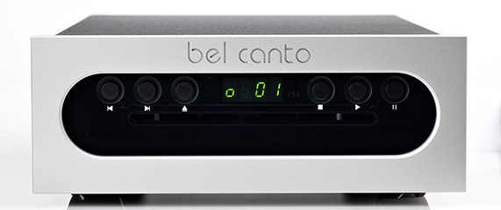
Audio Revolution declares it another winner for Bel Canto! “The CD3t would ideally be a terrific match with one of the Bel Canto DAC’s. At $1495, the CD3t is an outright steal. It is refined and elegant in both appearance and sound. As a final note Bel Canto, out of Minnesota, designs and manufacturers it’s products here in the USA. The CD3t is a superb product, and when mated with a great DAC, is an easy recommendation.” Read the full review here.

The Wall Street Journal raves: “For bookshelf audiophiles who like their separate components down to the individual power supply, Bel Canto's full range of modular matching half-size power amps, CD players, FM tuners and digital-to-analog converters (for your PC music) is a dream come true. Though they're about as small as '80s-era microsystems, these handmade-in-Minneapolis stackables deliver enough sound and power for speakers 10 times their size.”

Disc Compatibility |  | Red Book CD, CDR, CDRW, Hybrid SACD: CD Layer
Digital Outputs
Maximum Data Rate/Bit Depth |  | 44.1kHz/16bit
Digital Output types |  | AES/EBU XLR, SPDIF
AES/EBU Digital Output Level |  | 3V p-p, 110 ohms, 44.1K samples/second
SPDIF Digital Output Level |  | 0.6V p-p, 75 ohms, 44.1K samples/second
Additive jitter |  | < 100 pS RMS
Features
StreamUnlimited Slot-Load Mechanism
Power draw | 4 Watts
Sleep Mode power draw | <0.5W
Power Requirements | Internally set for: 120VAC 50-60Hz or 220-240VAC 50-60 Hz
Dimensions | 8.5” W x 12.5” D x 4.5” H (216 mm x 318 mm x 115 mm)
Weight | 12lbs. (5.5 kg)

Bel Canto Design, Ltd. • Minneapolis • MN • USA • www.belcantodesign.com

