
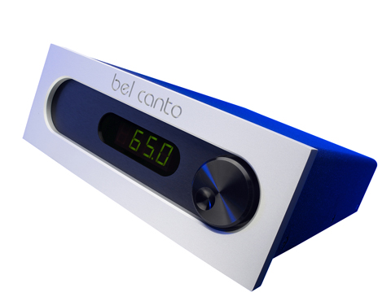

The Fastest, Simplest And Most Efficient Way To Convert Electrical Power Into Music!

Class-D Demystified
Class-D is commonly misunderstood to signify a Digital amplifier. It’s actually the 4th letter in succession of amplifier types: Class A, AB and C. What it really stands for is the fastest, simplest and most efficient way to convert electrical power into music. Our class-D amplifier architecture uses sophisticated class-A analog control circuitry to achieve low distortion and high dynamic range coupled with the eco-modern efficiency of our class-D output stage.

Every amplifier design has strengths and weaknesses. For years most enthusiasts didn’t think twice about spinning the electric meter with massive class-A and class-AB amps featuring their ringing heat sinks. Times have changed: Green, low-heat, ultra-efficient switch-mode power supplies and switching output stages make possible Bel Canto’s eco-friendly compact designs; place two Bel Canto products in the space formerly occupied by a large, hot-running, inefficient class-A design! We’re just saying…

Further performance advantages of class-D result from its lack of thermal wander tracking the audio signal and its inherent efficiency means only a minimal number of output devices are required resulting in a less complex, more reliable designs with short and fast signal paths. The custom active input stage on all the Bel Canto REF amplifiers limits noise and increases impedance to 100K single-ended and 200K balanced for improved system compatibility.

Bel Canto power supplies are packed with low-noise rectification and filtering that substantially increases energy storage and significantly lowers noise while reducing sensitivity to power line fluctuations. High-speed rectifiers, high-voltage film filter capacitors and high-energy storage pops the imaging out of the speakers with nuance, power and dynamics!

A full-bore setup might include a pair of REF500M monoblocks or for the power mad, REF1000M monos. You’ll want to know that a CD2/DAC3 and a pair of REF500 mono-blocks consume less power while playing than a 40 watt light bulb! Keep your system powered up, no guilt, no waiting!

Bel Canto music products are eminently satisfying, discrete and sleek enough to flatter any room. And they sound particularly awesome playing CDs or downloaded high resolution files from your laptop. We know what you want and makes what you need!

“I love the REF500s’ [now REF1000Ms] power without guilt, power without heat, and high performance without compromise ethos. The sound grabbed my attention right away … There was something about the way these components preserve the music’s drive; the ‘spaces’ between instruments are delineated like never before. So you see, Bel Canto isn’t just different, it’s better!”
-- Steve Guttenberg, Home Entertainment, CNET
“The Bel Canto REF1000 MkIIs [now REF1000Ms] are distinctive and expressive amplifiers. Far from having introduced cookie-cutter non-denominational ICE based devices, John Stronczer has imbued these amplifiers with the authority and frequency extension of the 1000ASP powerhouse, combined with a convincing harmonic congruence, and delightful warmth beginning from the lower midrange down-to the mid bass … There is seductive warmth in these agile monoblock amps that are filled with life, harmonic refinement, and a rare sense of space and 'being there'. Do not be deceived by the REF1000 MkIIs' conservative size and weight, or by the trite and obsolete urban legends surrounding class D amplification, which are barely kept alive by a shrinking hyper-nostalgic crowd. There is not a trace of 'digititis' ever to be detected in their excellent performance. Give them a careful audition: you will be excited by their authority, seduced by their agility, and will fall in love with their musicality.”
-- Guido Corona, Positive Feedback Online

About Bel Canto
Bel Canto Design has developed award-winning products for more than 15 years using the highest standards of design, engineering and production practices. Included in the Bel Canto line are a series of CD players, DACs, integrated amps, mono and two-channel amplifiers, an analog preamp, a companion phono stage with adjustable cartridge loading, and the USB Link 24/96 USB-to-SPDIF converter with more products you want on the way.

Our music products are made in Minnesota, and we subscribe to low-impact production methods that put little waste back into the system. Reduced packaging volume and lower transport weight reduces our environmental impact. We reuse or recycle more than 99% of the packing materials found in our incoming parts shipments, and each year we divert massive amounts of cardboard, paper, plastic film, and Styrofoam from landfills. Steel, aluminum, and other metal waste products are recycled and returned to the production stream.

Bel Canto Design, Ltd. • Minneapolis MN • USA • info@belcantodesign.com

Press Contact • Reviews • Images
Scull Communications • 212.807.0519
jscull@scullcommunications.com • www.scullcommnications.com
