

The FM1 Tuner for Frequency Modulation Fans
Tuned Up for Bel Canto and Other High Performance Systems

Ride the waves today with 24-bit/96kHz Digital Outputs and
Patented Digital IF Analog Tuner Front End

December 21st, 2010 • Minneapolis MN • Bel Canto Design, Ltd., manufacturers of analog and digital source components and amplifiers, is happy to inform that the long-awaited FM1 Tuner is now widely available.

Tune It Up with the FM1

The FM1 features patented analog FM receiver architecture and superior RF performance that rejects interference using digital IF processing. The FM1 includes advanced seek algorithms, adjustable soft mute, stereo blend, auto-calibrated digital tuning, and FM stereo processing. Digital signal processing (DSP) allows precise pilot rejection, selectivity, and unmatched audio quality as the digital IF section operates at 24-bits. Run the digital output into your favorite Bel Canto DAC or choose the FM1’s analog outputs derived from our High Dynamic Range Bel Canto DAC architecture.

The FM1 incorporates a digital processor for the European Radio Data System (RDS) and the North American Radio Broadcast Data System (RBDS) for station identification and performance information that’s displayed on the 8-digit alphanumeric display. The FM1 delivers unprecedented functionality and performance in a compact, easy to use package. It’s a perfect system companion for a Bel Canto DAC Control Center or preamp-based system.

Features
- Internal 24/192 DAC, 122dB dynamic range
- 24-bit/96kHz digital output
- 8-digit alphanumeric green LED display
- 10 station preselects, remote control
- RDS/RBDS Function
- RCA/XLR analog outputs
- AES/EBU, SPDIF, Toslink Digital Outputs
- Power Consumption On 6W, Off 0.0W
- Green, eco-friendly, low-heat, low noise, low power consumption

MSRP $1,499

Availability: Now

Click here to see complete specifications.

About Bel Canto

Bel Canto Design has developed award-winning products for more than 15 years using the highest standards of design, engineering and production. Included in the Bel Canto line are a series of CD players, DACs, integrated amps, mono and two-channel amplifiers, phono and line-level stereo analog preamps, and accessories like the USB Link 24/96 and Light Link 24/96, with more products on the way.

We manufacture in Minnesota and subscribe to low-impact production methods that put little waste back into the system. Reduced packaging volume and lower transport weight reduces Bel Canto’s environmental impact. We reuse or recycle more than 99% of the packing materials of incoming parts shipments, and we divert massive amounts of cardboard, paper, plastic film, and Styrofoam from landfills. Steel, aluminum, and other metal waste products are recycled and returned to the production stream.

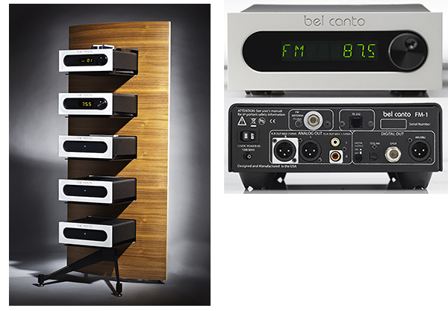

Bel Canto Design, Ltd. • Minneapolis • MN • USA www.belcantodesign.com

Press Contact

Scull Communications • 212.807.0519

jscull@scullcommunications.com • www.scullcommunications.com

Images and press releases • www.scullcommunications.com/pressresources.html

