


For Immediate Release

C5i DAC Integrated Amplifier is Innovations 2012

Design and Engineering Award Honoree

Digital • Analog • 24/96 USB • Phono • Headphone Amplifier

Visit Bel Canto at CES, the Venetian Suite 29-140

Minneapolis MN • 12/6/2011 • Bel Canto Design, Ltd., manufacturers of analog and digital source components and amplifiers is happy to announce the C5i DAC Integrated Amplifier is an Innovations Design and Engineering Award Honoree.

The One-Box Response
Why choose different components for your music downloads, computer, CD player, turntables, cable/satellite box or game consoles? Keep it simple with Bel Canto's compact, powerful e.One C5i DAC Integrated Amplifier to power it all!

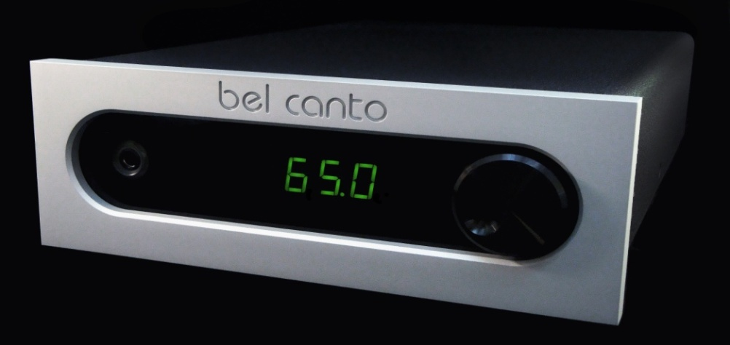
The C5i features 2 SPDIF and 2 TOSLINK inputs at 24/192, a USB input at 24/96, plus analog MM Phono and line level inputs on RCAs. Outputs include speaker binding posts, line level outputs on RCAs, and a front-panel headphone jack. It’s a powerful, energy efficient multimedia analog and digital media center. Just add speakers and the C5i’s versatility, performance and dynamic sound puts you in total system control.

The C5i Integrates Your Life… Just Add Speakers!
Think of the C5i as a fine-sounding, amazingly cool-running, high-output, low-power-usage analog and digital media center. It features low jitter, low noise, and excellent power supply isolation. Connect your computer, CD player, turntable, cable box or game console and you’re in total system control. Compare your analog collection to digital by simply changing inputs! Just add a pair of speakers and the listening room is open.

The Wall Street Journal raves: “For bookshelf audiophiles who like their separate components down to the individual power supply, Bel Canto's full range of modular matching half-size power amps, CD players, FM tuners and digital-to-analog converters (for your PC music) is a dream come true. Though they're about as small as '80s-era microsystems, these handmade-in-Minneapolis stackables deliver enough sound and power for speakers 10 times their size.”

About Bel Canto
Bel Canto Design has developed award-winning products for more than 15 years using the highest standards of design, engineering and production practices. Included in the Bel Canto line are a series of CD players, DACs, integrated amps, mono and two-channel amplifiers, an analog preamp, a companion phono stage with adjustable cartridge loading, the USB Link 24/96 USB-to-SPDIF converter, the 24/96 Light Link with more products you want on the way.

Bel Canto’s music products are made in Minnesota and subscribe to low-impact production methods that put little waste back into the system. Reduced packaging volume and lower transport weight reduces environmental impact. Bel Canto reuses or recycles more than 99% of the packing materials found in incoming parts shipments, and each year diverts massive amounts of cardboard, paper, plastic film, and Styrofoam from landfills. Steel, aluminum, and other metal waste products are recycled and returned to the production stream.



Bel Canto Design, Ltd. • Minneapolis MN • USA • info@belcantodesign.com

