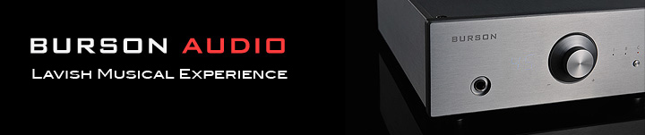
For Immediate Release

Burson Audio’s Conductor Virtuoso Now Shipping

Melbourne, Australia | December 9th, 2014 | Burson Audio, manufacturer of fine USB DAC/Headphone Amplifier/Preamplifiers, Headphone Amplifiers and stereo amplifiers, introduces the new Conductor Virtuoso superseding all previous Conductor models.

The Conductor Virtuoso
The Conductor Virtuoso is a USB DAC, Headphone Amplifier and Preamplifier in one elegant, beautifully-built package. Many audiophiles use an outboard DAC and headphone amplifier to drive their headphones or desktop systems. The Conductor Virtuoso is a highly-engineered yet modestly-priced component with up to 4 watts of power to drive any headphone with ease. Or consumers can use the Conductor Virtuoso’s preamp functions to make it the center of a headphone and speaker-based desktop system or a larger speaker system using Burson’s Timekeeper power amp.

How Virtuoso is it?
Burson has significantly upgraded and refined previous generations of the Conductor. Besides big power, the new Conductor Virtuoso includes a new, stunning 100-step volume control with a fresh and easy-to-read display. When the Virtuoso is turned on the volume indicators appear on the face of the thick, antiresonant aluminum front plate.

Consumers can choose from two interchangeable DAC boards with different sonic characteristics, and the modular design makes for no-fuss upgrades. Another important consideration is Burson doesn’t use densely-packed opamps but instead all discrete circuitry for superior tonality, clarity and a lower noise floor. The remote control is worthy of the Burson badge, carved from solid aluminum with no visible screws.

The touch and feel of Burson products matches their irresistible sound. They’ll pull you into the music in a visceral, exciting way for a lavish musical experience.

The Conductor Virtuoso is shipping now with the ESS9018 Sabre DAC at $1,995USD / €1,850 Euros. The Burr Brown PCM1793 version is priced at $1,495USD / €1,451 Euros.

The Big Update
Burson is completely updating its webpages and has hired Scull Communications to engage the press, write copy, market and promote the brand.

Burson Audio
www.BursonAudio.com
Burson Sales info@bursonaudio.com

