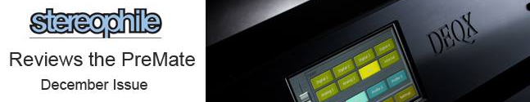
DEQX NEWSLETTER

Dear Colleagues,

It’s been a busy time for DEQX. First and foremost we’re sure you enjoyed the wonderful review in Stereophile of the PreMate in December’s issue. It was the strongest review we’ve ever had despite Kal Rubinson noting the manual was not for beginners. In any case, as we mentioned in the Manufacturers Reply most installations are done by dealers or online DEQXpert sessions. Read the review online here.

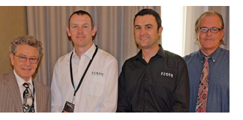
Michael Fremer of Analog Planet and Stereophile Magazine spoke very highly of the Kyron Audio Kronos speaker system at the Australian Audio & AV Show in Melbourne. A DEQX processor was part of the system and here's what Michael said: "Produced some of the best sound I have ever heard anywhere from an audio system." Left to right, Michael Fremer, Kyron's Leon Suter and Lee Gray, DEQX's Kim Ryrie. See his report here.

Positive Feedback Online gave DEQX an Audio Oasis Award for the Rocky Mountain Audio Fest exhibit in October. The new Premate+ was matched with Magnepan 1.7s, JL Audio F110 subs and a PLINIUS SB-301 300W power amp. Editor David Robinson: "We did a number of before-and-after switches, with various samples of music. Each time, the improvement was notable… the Maggies were transformed." The entire show report can be found here.

Jim Clements, a popular reviewer on Google+ this about our RMAF room: "DEQX had the most convincing demo yet of their room calibration system. When the calibration system kicked in, the stage expanded tremendously and there was a darker background with much more space between notes." See more here.

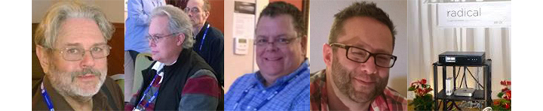

Left to right, Stereophile Editor John Atkinson, PFO Editor David Robinson, Reviewer Jim Clemment,
and the DEQX room at RMAF.

The entire team wishes you the best for the holiday season and a Happy and Prosperous New Year.

DEQX | Brookvale NSW | AUSTRALIA | Tel +61 2 9905 6277 | Fax +61 2 9905 8066
sales@deqx.com | http://www.deqx.com

