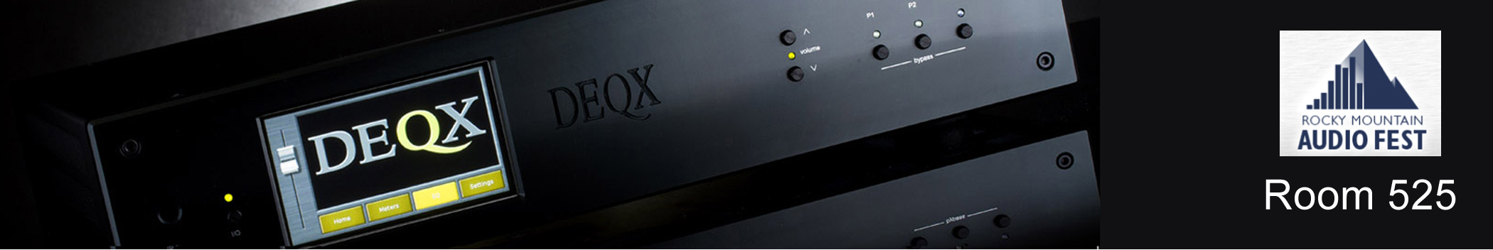
DEQX PreMate+ and HDP-5 Debut at Rocky Mountain Audio Fest Marriott Room 525

Brookvale Australia | October 6th 2014 | DEQX Pty Ltd, manufacturers of leading-edge Preamp Processors providing speaker calibration, crossover and room compensation will be exhibiting at the Rocky Mountain Audio Fest in the Marriott Tech Center in room 525. New product Introductions include the PreMate+™ and HDP-5™, both featuring a 4.3” 24-bit LCD touchscreen display. The PreMate and HDP-4 are still available.

PreMate+
The new DEQX PreMate+™ is for two-channel people whose family life may require certain compromises in speaker placement and cost. Plus it‘s for discerning audiophiles with better listening rooms who recognize that timing is everything and that room acoustics contribute to their speakers’ sound.

The PreMate+ is a full-function preamp processors that delivers comprehensive speaker and room calibration plus full preamp functionality with an extremely fine DAC. DEQX Preamp/Processors calibrate your listening space by removing speaker distortion with subsequent room compensation. The results are startling when timing, phase and amplitude accuracy are restored. Like the PreMate, the PreMate+ works with speakers and their built-in crossovers.

HDP-5
For ultimate flexibility, the new HDP-5 provides the best audio quality and highest level of functionality including volume control, Forensic Tone Control, and supports 3-way DEQX XO™ Active Crossovers. Using DEQX XO the HDP-5 replaces the speakers‘ crossovers and tailors each tri-amped channel for their individual drivers just as in pro audio. But unlike most active speakers DEQX achieves better results with linear-phase crossovers.

Touchscreen Display
The new A8 ARM 1GHz CPU with a 4.3” 24-bit LCD touchscreen with 480 x 272 resolution allows volume control, input and profile selections, and input VU levels or peak levels for all inputs and outputs. A settings page allows user-defined display options including dimming and turning the display off.

Join us in room 525 and be amazed how DEQX calibration transforms relatively inexpensive speakers by linearizing their native (anechoic) response. Additionally we’ll integrate a pair of subwoofers into the system while fixing room acoustic issues.

MSRP
PreMate+ $5,995 including USB-Audio input and Dayton EMM-6 calibrated measurement microphone
PreMate $4,995 including as above
HDP-5 $6,495 including as above
HDP-4 $5,495 including as above

Calibrate your space with DEQX
Most purchasers use DEQXpert Calibration Services provided by the dealer or online. If you run the software yourself we can help.

RMAF in the Marriott Tech Center Room 525
Friday October 10th to the 12th, 2014
4900 S Syracuse St., Denver, CO 80237

DEQX | Brookvale NSW | Australia | Tel +61 2 9905 6277 | Fax +61 2 9905 8066
sales@deqx.com | http://www.deqx.com

