


by

Introducing the ADL iD-30P Series iDock Cable
For The Best Performance You Can Buy!

Tokyo, Japan • Furutech Co., Ltd., manufacturer of analog and digital audio and video cable plus a wide range of accessories, debuts the ADL (Alpha Design Labs) iD-30P series personal audio cables.

ADL uses Furutech’s Pure Transmission Technology to create high-value, innovative designs that everyone can afford. And in the age of personal, portable electronics everyone carries their music with them to connect to iDocks, headphone amps, home audio and even car systems. And there’s no better sounding (or hip-looking) cables than the iD30P series that comes in three versions to make every important connection you need.
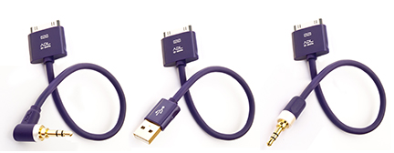
ID-30PS-0.15M iD-30PA-0.15M iD-30PL-0.15M
MFi Licensed and Certified

Not Just Another Pretty Face
The iD-30P series are no ordinary cables; they’ve engineered and produced with Furutech’s Pure Transmission technology and feature silver-plated α (Alpha) OCC conductor (28AWG) for minimal transmission loss and 24k gold-plated USB A-type or 3.5mm stereo connector straight or angled. The cable achieves top-grade noise isolation using double-layer shielding – aluminum foil and tinned copper – in a RoHS-compliant sheath. The main conductors are treated with Furutech’s α (Alpha) Process – a deep cryogenic and demagnetizing process. The result is outstanding, wideband, colorful and engaging sound.

Construction

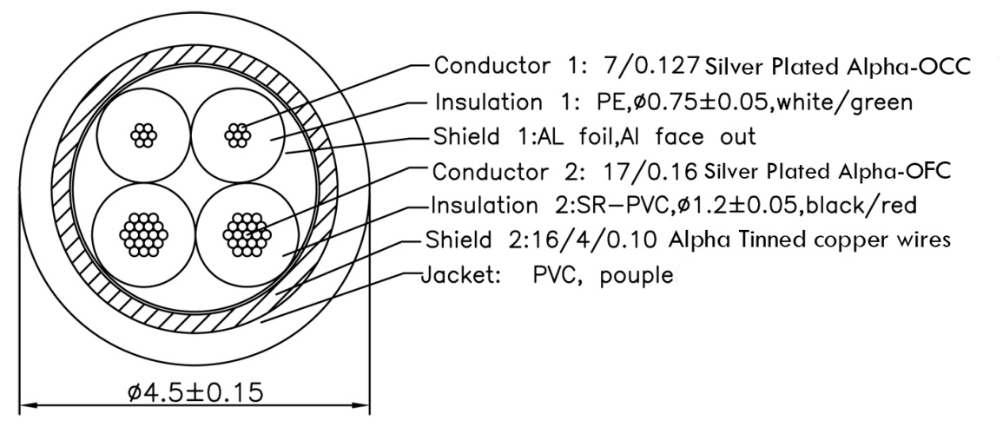

You’ll enjoy the best sound around while looking – and sounding – as hip as they come!

Connector Types
iD-30PA-0.15M: Apple 30-Pin iDock-to-USB A
iD-30PS-0.15M: Apple 30-Pin iDock-to-3.5 Straight
iD-30PL-0.15M: Apple 30-Pin iDock-to-3.5 Angled

Cable Length: 15cm (0.5ft)

iPod, iPhone, iPad are trademarks of Apple Inc.

ADL product enquiries email: service@adl-av.com
Furutech Co., Ltd. Tokyo Japan
www.adl-av.com



