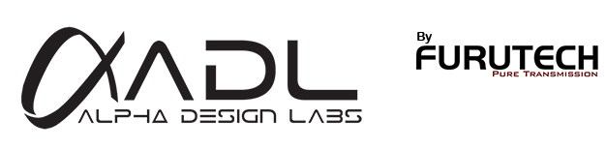

Introducing the Extraordinary ADL iDevice iD35SP 3.5mm Companion Stereo Cable
The Highest Performance Personal Stereo Cable You Can Find!

Tokyo, Japan • Furutech Co., Ltd., manufacturer of analog and digital audio and video cable plus a wide range of accessories, debuts the ADL (Alpha Design Labs) iD35SP 3.5mm analog stereo cable, a perfect companion for the Cruise Portable Headphone Amplifier. ADL creates quality products built to Furutech’s Pure Transmission standards at surprisingly affordable prices.

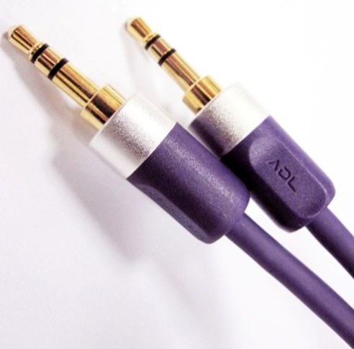
Furutech is justifiably proud of its reputation for engineering, build quality and performance, and has won the loyal support of audio enthusiasts worldwide for their finely made and beautiful sounding cables and audio accessories. Now Furutech greatly expands its reach with a new entry-level line called ADL (Alpha Design Labs). ADL was created by Furutech to imbue its Pure Transmission Technology into carefully engineered innovative designs that everyone can afford. ADL components and cables are made with the same dedication to total resonance control and refinement as all of Furutech's many cables and accessories.

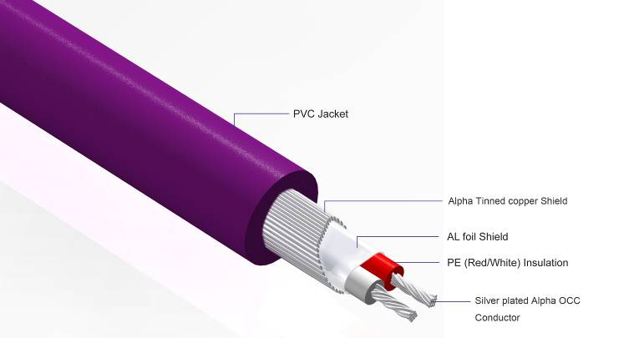
When it’s impractical to connect your Cruise headphone amp via its USB input we’ve created the iD35SP 3.5mm analog stereo cable. The iD35SP features silver-plated α (Alpha) OCC conductor for minimal transmission loss and 24k gold-plated connectors. The cable achieves superior noise isolation with two-layer shielding – aluminum foil and tinned copper -- in a RoHS-compliant sheath. The main conductors are treated with Furutech’s α (Alpha) Process – a deep cryogenic and demagnetizing treatment.

USB sounds best, but the iD35SP comes in a close second! Either way you’ll enjoy some of the best sound available while looking – and sounding -- as hip as they come!

Cable Length: 0.6m (2-ft) /1.2m (4-ft) / 1.8m (6-ft) / 3.6m (12-ft) / 5.0m (16.5ft)

About Alpha Design Labs
Furutech is justifiably proud of its reputation for engineering, build quality and performance. ADL was created by Furutech to imbue its Pure Transmission Technology into carefully engineered innovative designs that everyone can afford for creating high-level computer-based sound. ADL components are made with the same dedication to total resonance control and refinement as all of Furutech’s many cables and accessories. ADL product enquiries email: service@adl-av.com • Furutech Co., Ltd. Tokyo Japan • www.adl-av.com

