

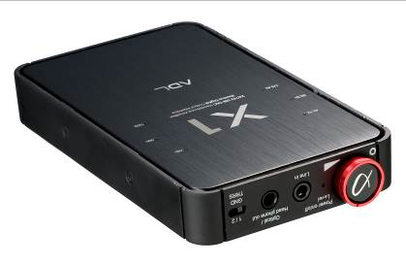

ADL X1 24/192 USB DAC and
Headphone Amplifier


Goes Anywhere • Stacks Easily • Rechargeable Li-Ion Battery • Digital Inputs For iDevices or PCs • Superb Sound • Perfect with ADL H118s

ADL – Alpha Design Labs – creates innovative, smart-looking components for computer-based systems as well as personal and portable electronics. Tokyo-based ADL by Furutech™ aims high using the best materials and innovative design for an expanding line of Japanese-designed precision products including the superb sounding 24/192 ADL X1 Headphone Amp.

Headphone listening is an intimate sonic experience and most enthusiasts employ headphone amplifiers and a good pair of headphones much like ADL H118. Headphone amplifiers determine the quality of sound in hand with the headphones so both must be technically capable and offer fine sound as well.

The X1 is small, discrete but highly specified with inputs supporting iOS digital at up to 16/48 via APPLE MFI certified USB cable for iPod, iPhone and iPad devices. The X1 also runs 24/192 SPDIF with high resolution files from MAC and PC via USB output. There’s an analog line-level 4-pin 3.5mm input and a 4-pin 3.5mm output for headphones in the 12~600 ohm range. The 4-pin input supports 3.5mm Remote and Mic Earphones. The 3.5mm TOSLINK optical output delivers SPDIF up to 24/192. There’s a convenient GND TRRS switch making it easy to change from one 4-pin set of ‘phones to another. No drivers are needed with Mac computers while a single standard driver is available for Windows computers.

Connectivity

- USB mini-B socket for USB A output from PCs and charging battery
- USB A socket for iDevice output via APPLE MFI-certified USB cable
- Headphone and line out-1 (front) (4-pin) 3.5mm connector for headphones and analog output
- Headphone and line out-2 (rear) (3-pin) combined 3.5mm connector for headphones
- Line input (4-pin): 3.5mm connector for analog input (switched)
- Mini-optical output connector

When using both 3.5mm headphone line-out connectors simultaneously we advise using near-impedance-matched headphones

Features

- Beautifully-finished aluminum and plastic casing
- Supports iOS, Macs and PCs
- Stacks easily
- Fits in the palm of your hand
- Enjoy music anywhere
- Doesn’t draw power from connected iDevice’s battery
- Headphone and output can connect to home stereo system
- Line input improves sound of portable analog audio sources
- Switchable to match different smartphone types

Specifications

- High-quality volume control and On/Off switch (front)
- Gold-plated 3.5mm input connector: Analog line input (switched)
- Gold-plated 3.5mm output connector-1: Headphone or line-out
- Gold-plated 3.5mm output connector-2: Headphone or 3.5mm optical output for 24/192 (MAX) SPDIF
- 4-layer gold-plated printed circuit board with >1oz copper thickness
- Gold-plated USB A socket for 16/48 iDevices (iPod/iPhone/iPad)
- Gold-plated USB mini-B connector for 24/192 PC operation
- Recharges via PC USB connection or AC/DC switching power adapter
- Attractive aluminum cover and plastic body
- Max headphone output at 1%THD @ 1KHz
40mW (12 ohms), 65mW (16 ohms), 100mW (32 ohms), 107mW (56 ohms), 36mW (300 ohms), 19mW (600 ohms)
- Channel separation 60～64dB (1KHz) 33ohms -50dB/<=±3dB
- Frequency characteristics 20Hz～20kHz (±0.5dB)
- Total Harmonic Distortion 0.033% (33ohms) , <0.02% (300ohms) , 0.0085% (600ohms)/1mW
- S/N Ratio 95.5dB/32ohms , 98.1dB/56ohms , 101.6dB/300ohms, 102.1dB/600ohms
- Charge time approximately 4～5 hours (AC/DC 5V, 1.0-2.0A switching adaptor)
- Charge time: approximately 7 hours (DC 5V 0.5A USB bus power)
- Music playback time up to 7.5 hours when fully charged
- Dimensions 68 (W) x 118 (D) x 16.5 (H) mm
- Weight: 147g Approx.

Front Controls and Indicators

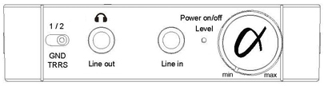
- Headphone and line-out-1 (4-pin): 3.5mm connector for headphones and analog output
- Line input (4-pin): 3.5mm connector (switched)
- Volume: Rotary-type variable resistor with power on/off
- Charging Indicators: RED GREEN and ORANGE LEDs
RED indicates charging/GREEN indicates full charge/ORANGE indicates low charge
- GND TRRS Switch: Switchable to match different 4-pin headphone types (SONY or APPLE)

Rear Panel

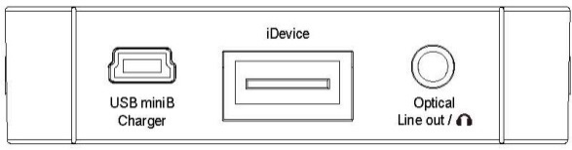
- USB A socket for APPLE MFI Certified USB cable via iDevice
- USB mini-B socket for USB cable via PC and to charge battery
(Internal DC3.7V 2600mAh Li-ion Type rechargeable battery)
- Headphone and line-out-2 (3-pin): Combined 3.5mm and mini-optical output connector

Top Panel LED Indicators

- USB DAC MAC or PC USB connection: Indicates source sample rate (44.1 / 48 / 88.2 / 96 / 176.4 / 192kH)
- USB DAC analog source on 3.5mm line-in connector: Indicates sample rate at 48kHz
- Digital connections: Indicates sample rate (LED flashing) at 44.1kHz (not 48kHz) connected with Apple MFi-approved USB cable
- iDevice analog connections: Indicates sample rate (LED on) at 44.1kHz
- Computer-based files with iTunes on Mac or PC: Indicates sample rates of computer (44.1 / 48/ 88.2 / 96 / 176.4 /192kH)
- Computer based files with iTunes and Windows XP: Sample rates cannot be set so the X1 indicates 44.1kHz

Bottom Panel

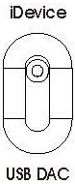

- Input selection: Switch between USB A or USB mini-B (USB-A socket for iOS or USB mini-B socket for PCs - When between iDevices and USB the X1 must be reset, simply switch the ADL X1 on and off

Technical Specifications

- 24-bit/192kHz XMOS High-Performance Streaming Controller supports ASIO and Asynchronous mode
- USB 2.0 High Speed compliant supporting 8/16/32/44.1/48/88.2/96/176.4/192 kHz sampling rates
- High-performance ESS-ES9023 24-bit/192kHz DAC chip
- Maxim MAX9724C Power IC , Low-RF Direct-Drive Stereo Headphone Amplifier with 1.8V compatible shutdown
- TI- LMV832 Dual 3.3 MHz EMI-Hardened Low-Power CMOS OP AMP
- Power Supply 1: DC 5V 500mA ~ 2000mA
- Power Supply 2: DC 3.7V 2600 mAh Li-ion rechargeable battery

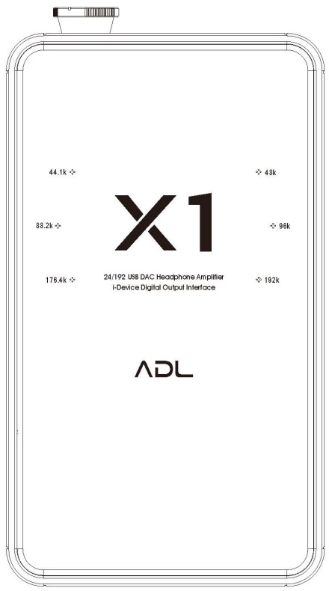
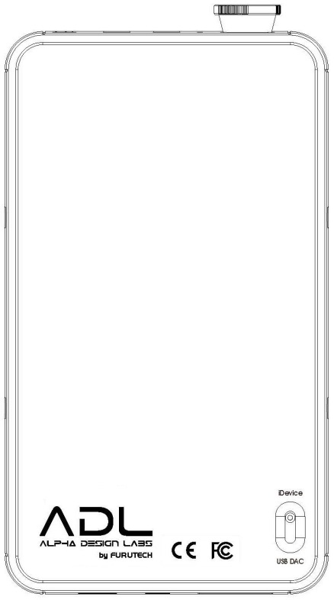

www.adl-av.com
ADL product enquiries service@adl-av.com
Furutech Co., Ltd. Tokyo, Japan

