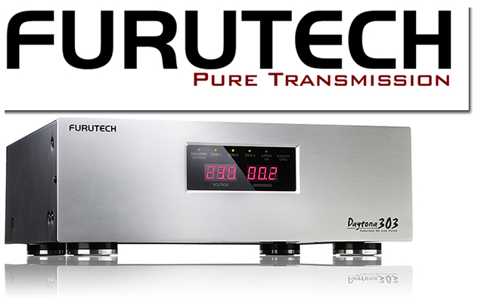

The Daytona 303 Multi-Mode AC Filter/Power Distributor
Featuring Resonance-Damped Receptacles and Locking Plates
EMI-Absorbing Formula GC-303

Furutech Co., Ltd., manufacturer of ultra refined analog, digital, video cable and accessories, pulls the cover off the e-TP303 Daytona Multi-Mode AC Filter/Power Distributor, providing comprehensive protection and filtering for your audio or home theater system.

The Daytona: 24 Hour Protection for Pro A/V and High Performance Enthusiasts
The Daytona 303 is a sophisticated, luxuriously made single-chassis power distributor and filtering unit that eliminates many common problems caused by massively contaminated electrical power lines. The AC mains waveform is heavily distorted by ground noise, voltage spikes and sags, high frequency power supply noise from other components in your own system, plus high frequency digital noise radiating from processors and digital interconnects.

There are also distortion products at the top and bottom of the AC waveform created by switch-mode power supplies in small electronics and charging devices on the same circuit. Additionally, you’re never alone; your residential AC supply is shared with other apartments, homes, and businesses on the same utility transformer. That’s why many audio and video enthusiasts notice their systems are more enjoyable late at night or on weekends!

Under the Hood
Like a Daytona GT racer, the Furutech e-TP303 is purpose-made to comprehensively protect your audio and video system with 5250 joules of surge protection plus Stage 3 filtering that dramatically reduces induced, radiated and ground-borne noise. Micro-circuits monitor line voltage and disconnects instantly if dangerous over- or under-voltages occurs, then reconnects once the power returns to safe levels.
The Daytona also features three ultra-advanced isolating filter sections including two analog, two digital, plus another pair of ultra-high-current audio filters. The Daytona also sports 12 surge-protected AC outlets, 3 pair of protected coaxial connections, and 1-in/2-out fully-protected phone line connections.

On the Track
The Daytona 303 relieves your system of flat, hard, and grainy high frequencies, a thick and bloated midrange over wooly bass, a loss of air, detail and soundstage instability. On video displays the picture resolution is sharper, with no ghosting, color shift, snow, or vertical and horizontal lines to spoil the view. If this sounds familiar, you need a Furutech Daytona 303!

Features
- 4 unfiltered outlets • FT-D15Ar x 2
  - Power amplifiers • Direct 1
  - Preamplifiers and analog devices • Direct 2
- 6 Digital filtered outlets • FP-15A-N1r x 3
  - DVD and DVR • Filter 1/Zone 1
  - CD, Cable and SAT • Filter 2/Zone 2
  - TV and projector • Filter 3/Zone 3
- All Furutech Pure Transmission Receptacles feature nonmagnetic rhodium-plated α (Alpha) phosphor bronze fittings
- Beautifully-crafted highest-grade aluminum panels and painted steel chassis
- Effectively shields against RFI (Radio Frequency Interference)
- Layer of EMI-absorbing Formula GC-303 bonded to bottom plate
  - Effectively shields against EMI (Electro Magnetic Interference)
- Internal wiring: Furutech Alpha-10, 5.5 sq. mm (10 AWG) for low electrical resistance
- Conductors insulated with resonance-absorbing tubing
- Front panel • 8 indicators for abnormal operation
  - Abnormal voltage indicator • Red
  - Filter 1, 2, 3/Zone 1, 2, 3 • Green
  - Correct Path indicator • Green
  - Breaker indicator • Red
  - Digital voltage meter • Red
  - Digital amperage meter • Red
- Rear panel
  - Attachable LED lamp for easy viewing
  - Three sets of surge-protected coaxial terminals
  - Surge-protected 3-way phone connections
    - Input x 1 • Output x 2
  - Remote control triggers
    - AC 100~120V In/DC 3~30V In/DC 12V Out
  - Standard rack mounting plates
  - Sequence switch
  - Voltage selector switch for 120V AC (60Hz) or 100V AC (50/60Hz)
- All conductors treated with Furutech’s α (Alpha) Cryogenic and Demagnetizing Process

Designed for home enthusiasts and professional installers working with high-end home entertainment systems, recording and touring venues, Furutech equipped the Daytona with these additional features:
- Rack-mountable hardware
- Digital readout simultaneously monitors voltage and current
- Surge-protected phone connections
- 3 pairs of protected 2.5GHz coaxial connections
- 3 remote trigger controls
- Front and back XLR lamp connectors so you can see what you're doing!
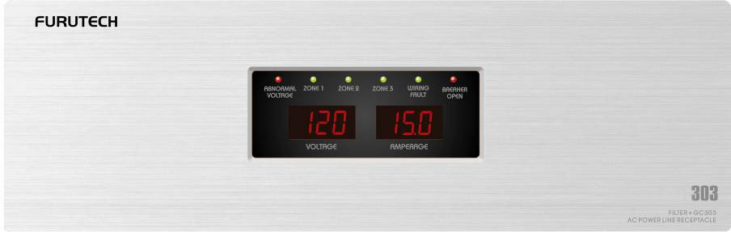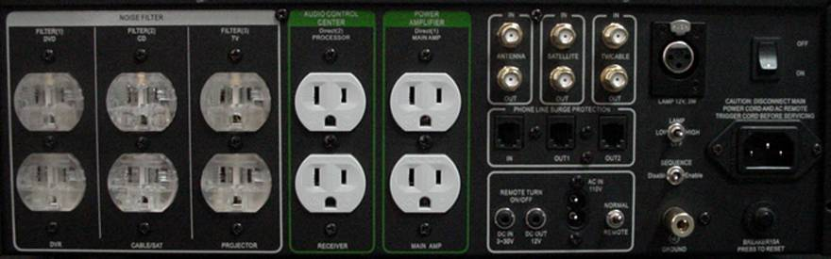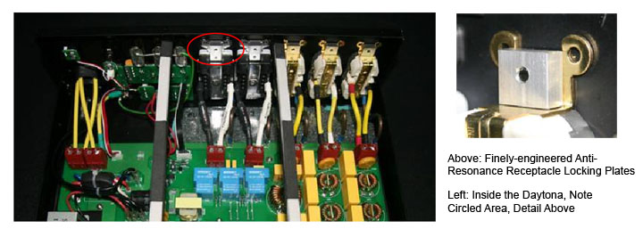
The Insider’s View

Circuit Path

About Furutech
Furutech makes a wide variety of high performance 15A and 20A A/V cable and power connectors and parts, as well as distribution/filtering products like the new 120Hz standard xv1.3 HDMI cable, Ag-12 Silver Tonearm Cable, Pure Power 6, e-TP4+4, e-TP609, e-TP619 and e-TP60 Power Distributors, and e-TP80 Power Filters, the deStat, a fan-driven, Balanced Ion Drive device for totally eliminating static from LPs and CDs, DF-2 LP Flattener, lightweight and stylish FRD Room Diffusion Panels, PC-2 Disc Pure Cleaner, and their own very special NANO Liquid Contact Enhancer, plus even more fine cable and OEM
products.

Circuit Path
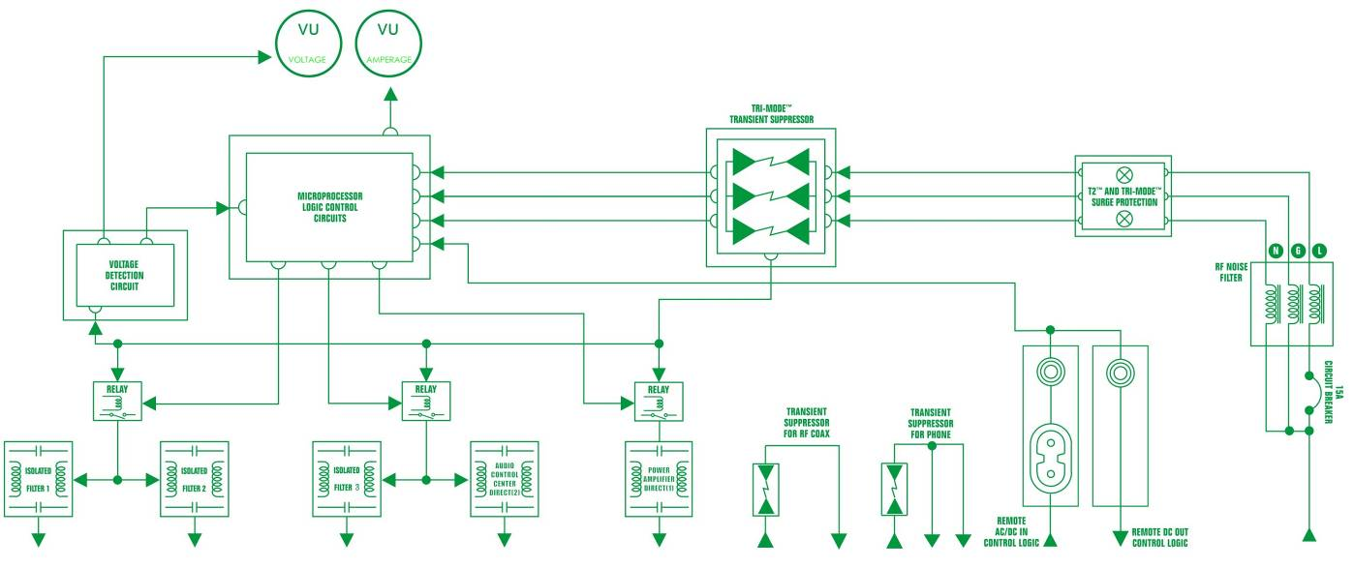

Awards
DeMag Wins CES Best of Innovations ‘07
e-TP609 Wins Absolute Sound Product of the Year Awards ‘07
G-302A-18 Power Cord Wins 6moons Blue Moon Award ‘07
Evolution Cables Wins Best of 2007 Awards Enjoy the Music
Reference III Cables Win Absolute Sound Editors’ Choice ‘07/’08
AG-12 Phono Cable Wins the SoundStage Network’s Reviewers’ Choice Award ‘08
Ag-12 Phono Cable is Tone Audio’s Exceptional Value Award ‘08
Monza LP Stabilizer, Silver Arrows Phono Cable, La Source Headshell Extensions
All Win Tone Audio’s Accessory Products of the Year
xv1.3 HDMI Cable Wins Positive Feedback’s Brutus Award ‘08
FI-50 Piezo Ceramic Series Connectors Win CES Best of Innovations ‘09
Monza LP Stabilizer Wins Positive Feedback’s Brutus Award ‘09
Select Series Fuses Win Positive Feedback’s Brutus Award ‘09
GT2 USB Cable is Playback Recommended ’09

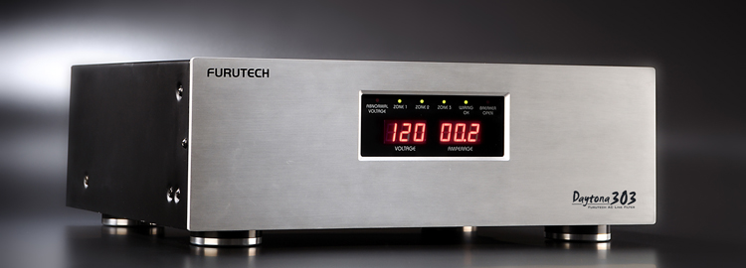

Make A More Powerful Connection with Furutech!
FURUTECH CO., LTD • service@furutech.com • www.furutech.com
FURUTECH reserves the right to change product specifications without prior notice


Press • Info • Review • Images • Scull Communications • 212.807.0519
jscull@scullcommunications.com • www.scullcommunications.com
www.scullcommunications.com/pressresources.html

