

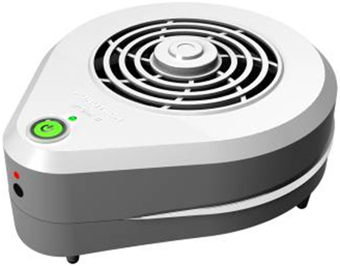

Furutech Destat II
Removes Dust and Static from Analog and Digital Components and Media
Improved Ion Flow Generator Features • More Emitters than Original Model
A companion piece to the Furutech DeMag LP Demagnetizer

Tokyo, Japan • Furutech Co., Ltd., manufacturer of analog and digital audio and video cable plus a wide range of accessories, unveils the successor to the original Destat, the Destat II.

Zap!
The Destat II is incredibly easy to use and removes dust and static charge from audio/video media with a 10 second treatment. High performance enthusiasts know that static charges on analog and optical media – LPs, CDs and DVDs – can lead to sudden and distracting noise that compromises the experience. Simply place your media on or hold it under the Destat II and press one button! The powerful fan removes dust while the Destat II’s improved Ion Flow Generator – now featuring 4 emitters that simultaneously generate static-eliminating ions as opposed to the previous model’s 2-emitter alternating method.

Almost every A/V system component benefits from eliminating its static charge. Use the Destat II on the audio/video equipment itself – best to turn them off during treatment – plus power cords, line-level interconnects, speaker cables, and even metal record clamps!

The Destat II is small, efficient, with a rechargeable battery and easy to use with one hand. Each dust and static removal takes just 10 seconds. Plus a safety circuit prevents any small shocks from the Balanced Ion Flow Generator. You’ll be amazed at the results!

Make A More Powerful Connection with Furutech!

About Furutech
Furutech makes a wide variety of high performance 15A and 20A A/V cable and power connectors and parts, as well as distribution/filtering products including the 120Hz standard xv1.3 HDMI cable, GT2 USB 2.0 and GT3 USB 3.0 cables, Ag-12 Silver Tonearm Cable, The Silver Arrows Tonearm Cable, La Source Headshell Wires, Monza LP Stabilizer Weight, the new Lineflux and Evolution II series, Pure Power 6, e-TP4+4, e-TP609, e-TP615 and e-TP60 Power Distributors, and e-TP80 Power Filters, deMag Disc and Cable Demagnetizer, PC-2 Disc Pure Cleaner, and their own very special NANO Liquid Contact Enhancer, plus even more fine cable and OEM products.

Awards
DeMag Wins CES Best of Innovations ’07 • e-TP609 Wins Absolute Sound Product of the Year Awards ’07 • G-320A-18 Power Cord Wins 6moons Blue Moon Award ’07 • Evolution Cables Wins Best of 2007 Awards Enjoy the Music • Reference III Cables Win Absolute Sound Editors’ Choice ‘07/’08 • AG-12 Phono Cable Wins the SoundStage Network’s Reviewers’ Choice Award ’08 • Ag-12 Phono Cable is Tone Audio’s Exceptional Value Award ’08 • Monza LP Stabilizer, Silver Arrows Phono Cable, La Source Headshell Extensions All Win Tone Audio’s Accessory Products of the Year • xv1.3 HDMI Cable Wins Positive Feedback’s Brutus Award ’08 • FI-50 Piezo Ceramic Series Connectors Win CES Best of Innovations ’09 • Monza LP Stabilizer Wins Positive Feedback’s Brutus Award ’09 • Select Series Fuses Win Positive Feedback’s Brutus Award ’09 • GT2 USB Cable is Playback Recommended ’09 • Torque Guard Speaker Binding Posts Innovations Honoree ’11.

FURUTECH CO., LTD. • service@furutech.com

Press • Info • Review • Images
Scull Communications • 212.807.0519
jscull@scullcommunications.com • www.scullcommunications.com
www.scullcommunications.com/pressresources.html

