
Alpha Design Labs by Furutech Formula 2 USB 2.0 Cables
24k Gold-Plated Nonmagnetic USB 2.0 Connectors
Silver-Plated α (Alpha) OFC Conductors

Tokyo, Japan • September 13th 2010 • Furutech Co., Ltd., manufacturer of analog and digital audio and video cable plus a wide range of accessories, debuts ADL (Alpha Design Labs), quality products built with Furutech’s Pure Transmission Engineering expertise at surprisingly affordable prices. ADL’s second product release is a refined, high performance yet cost-effective USB cable for computer-based DAC systems like Alpha Design Labs own GT40 24/96 USB DAC/Analog Recorder.

Hard Disk Management
Computer-bound music enthusiasts with large collections of music on hard disk require a top-quality USB cable for DACS like Alpha Design Labs’ GT40 24/96 USB DAC/Analog Recorder. ADL created a high performance yet low cost USB 2.0 cable to pair with the GT40 that offers high levels of resolution, openness and musicality from computer files. CD Redbook 16/44.1 and especially 24/96 files reveal a vivid, captivating sound unheard of at this price.

Pure Transmission Engineering begins with silver-plated α (Alpha) OFC conductors and a special-grade high-density polyethylene insulation/dielectric. As illustrated below Formula 2 features three-layer shielding and elegant, beautifully-engineered 24k gold-plated USB 2.0 connectors. As with Furutech’s more highly specified GT2 and GT3 USB cables the wrap includes damping and insulating materials keeping mechanical ringing from affecting the sound. A carefully engineered clamp improves grip and keeps both mechanical and electrical distortion at bay.

The result is much as you will hear from our GT2 USB cable: Clear and open highs, elegant midrange textures, powerful bass, and an enhanced sense of the sheer palpability of the music you’ll enjoy.

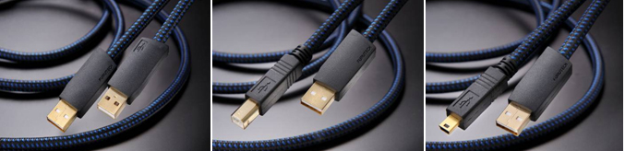

Formula 2 USB A-A A-B A-miniB
Formula 2 USB cables are available now in the US ranging in price -- depending on length -- between $43 for 0.6 meters to $102 for a 5.0m length.

Drive Your Computer Music System to First In Class!

Construction and Materials
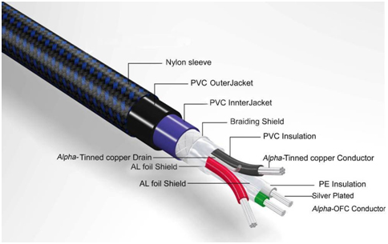

Features
- Main conductor: Silver-plated α (Alpha) OFC Conductors
- Main Insulation: Special-grade high-density polyethylene
- 3-layer shield construction for improved noise insulation
- Connectors: Furutech-engineered 24k gold-plated USB series Connectors
- The best damping and insulation materials for improved frequency extension and tonal balance
- Cable Types
  - Formula 2 USB-A (Type A-A) / USB-B (Type A-B) / USB-mini B (Type A-mini B)
- Cable Lengths
  - 0.6m (2ft) / 1.2m (4ft) / 1.8M (6ft) / 3.6m (12ft) / 5.0m (16.5ft)

Item |  | Specifications
 |  | 28AWG (1pr) | 24AWG (2C)
Conductor | Material | Silver-plated α (Alpha) OFC | α (Alpha) Conductor
Conductor | Construction (pc/mm) | 7/0.127 | 7/0.20
Insulation | Material | Special-grade high-density polyethylene (White/Green) | Special grade SR-PVC  (Red/Black)
Insulation | Avg. Thickness (mm) | 0.34 | 0.25
Insulation | Diameter (mm) | 0.9±0.05mm | 1.5±0.05mm
Shield-1 | Method | 100% Aluminum/Mylar foil wrap | -------------
Drain Wire | Material | α (Alpha) Conductor
Drain Wire | Construction (pc/mm) | 7/0.16
Shield-2 | Method | Al/Mylar, outside 100% coverage with 25% overlap
Shield-3 | Method | 0.1mm braided α (Alpha) Conductor
Sheath-1 | Material | RoHS-compliant flexible PVC (Blue)
Sheath-1 | Diameter (mm) | 4.5±0.15
Sheath-2 | Material | RoHS-compliant flexible resonance-damping PVC (Black)
Sheath-2 | Diameter (mm) | 6.0±0.15
Sleeve | Material | Nylon yarn braid (Black / Blue)
Overall Diameter (mm) |  | 6.4 ± 0.15

Electrical Properties
Item | Specifications
Max. Conductor Resistance | 28AWG:192.2 Ω/km | 24AWG:98 Ω/km | JIS3005 | 6 | 20℃
Min. Insulation Resistance | 100 MΩ/km |  | JIS3005 | 9.1 | 20℃
Dielectric Strength | AC 500 V/1min |  | JIS3005 | 8
Characteristic Impedance | 90±15%Ω |  | at 10mHz
Capacitance | 20 pf / ft |  | at 1kHz
Transmission Delay Time | 30±15%ns

Put Your Computer-Based Audio System on the Podium with
ADL Formula 2 USB Cables

About Alpha Design Labs
Furutech is justifiably proud of its reputation for engineering, build quality and performance. ADL was created by Furutech to imbue its Pure Transmission Technology into carefully engineered innovative designs that everyone can afford for creating high-level computer-based sound. ADL components are made with the same dedication to total resonance control and refinement as all of Furutech’s many cables and accessories.

About Furutech
Furutech makes a wide variety of high performance 15A and 20A A/V cable and power connectors and parts, as well as distribution/filtering products including the 120Hz standard xv1.3 HDMI cable, GT2 USB 2.0 and GT3 USB 3.0 cables, Ag-12 Silver Tonearm Cable, The Silver Arrows Tonearm Cable, La Source Headshell Wires, Monza LP Stabilizer Weight, the new Lineflux and Evolution II series, Pure Power 6, e-TP4+4, e-TP609, e-TP615 and e-TP60 Power Distributors, and e-TP80 Power Filters, deMag Disc and Cable Demagnetizer, PC-2 Disc Pure Cleaner, and their own very special NANO Liquid Contact Enhancer, plus even more fine cable and OEM products.

Furutech Awards
DeMag Wins CES Best of Innovations ‘07
e-TP609 Wins Absolute Sound Product of the Year Awards ‘07
G-302A-18 Power Cord Wins 6moons Blue Moon Award ‘07
Evolution Cables Wins Best of 2007 Awards Enjoy the Music
Reference III Cables Win Absolute Sound Editors’ Choice ‘07/’08
AG-12 Phono Cable Wins the SoundStage Network’s Reviewers’ Choice Award ‘08
Ag-12 Phono Cable is Tone Audio’s Exceptional Value Award ‘08
Monza LP Stabilizer, Silver Arrows Phono Cable, La Source Headshell Extensions
All Win Tone Audio’s Accessory Products of the Year
xv1.3 HDMI Cable Wins Positive Feedback’s Brutus Award ‘08
FI-50 Piezo Ceramic Series Connectors Win CES Best of Innovations ‘09
Monza LP Stabilizer Wins Positive Feedback’s Brutus Award ‘09
Select Series Fuses Win Positive Feedback’s Brutus Award ‘09
GT2 USB Cable is Playback Recommended ’09

Alpha Design Labs • www.adl-av.com • service@adl-av.com

Info • Press • Images • Reviews
Jonathan Scull • Scull Communications • 212 807.0519
jscull@scullcommunications.com • www.scullcommunications.com www.scullcommunications.com/pressresources.html

