

The Best and Most Refined Binding Post on the Planet?
Furutech Torque Guard Binding Posts Model FT-809
Premier Performance and Legendary Build Quality

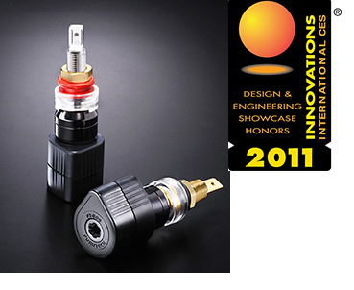
The critical binding post connection often proves the weakest link in the quest for tight, low-distortion signal. Change your cables a few times and speaker binding posts can loosen. It’s bad enough in modestly-priced speakers where the simple remedy is to unscrew the back plate and tighten the offending nut. With expensive stand-mounted monitors or larger, more costly speaker systems why take the risk? The Torque Guard binding post sits at the very highest rung of build quality and musical performance, maintaining the tightest, most noise-free and undistorted signal path possible.

Furutech’s beautifully finished, beautiful sounding Torque Guard Binding Posts are the result of meticulous engineering and careful audition of various suitable materials. The FT-809 features an α (Alpha) pure copper conductor for minimal impedance and extremely nonresonant polycarbonate housing and eutectic copper alloy fixed ring. The unique patent-pending Torque Guard technology, which prevents over-tightening, allows each post to be evenly tightened for improved channel balance and signal transfer.
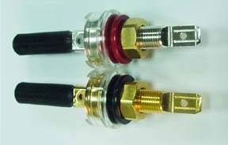

Features and Materials
- Patent-pending Torque Guard construction
- Main conductor: α (Alpha) machined-from-solid pure copper rhodium or 24k gold plated
- Central conductor pure copper post
- Housing: Nylon/fiberglass with piezo ceramic and carbon damping material
- Nylon (red/white) and Polycarbonate (clear) insulation
- Connections: Soldered or Crimp termination
- Specified for core diameters up to 4.5mm
- Dimensions: Housing: 25.0ψ x 30mm (L) x 38.9mm overall height
- Insulation: Polycarbonate (Clear) 19.3ψ x 7.3mm(H)
- Total overall length: 74.6mm approx.
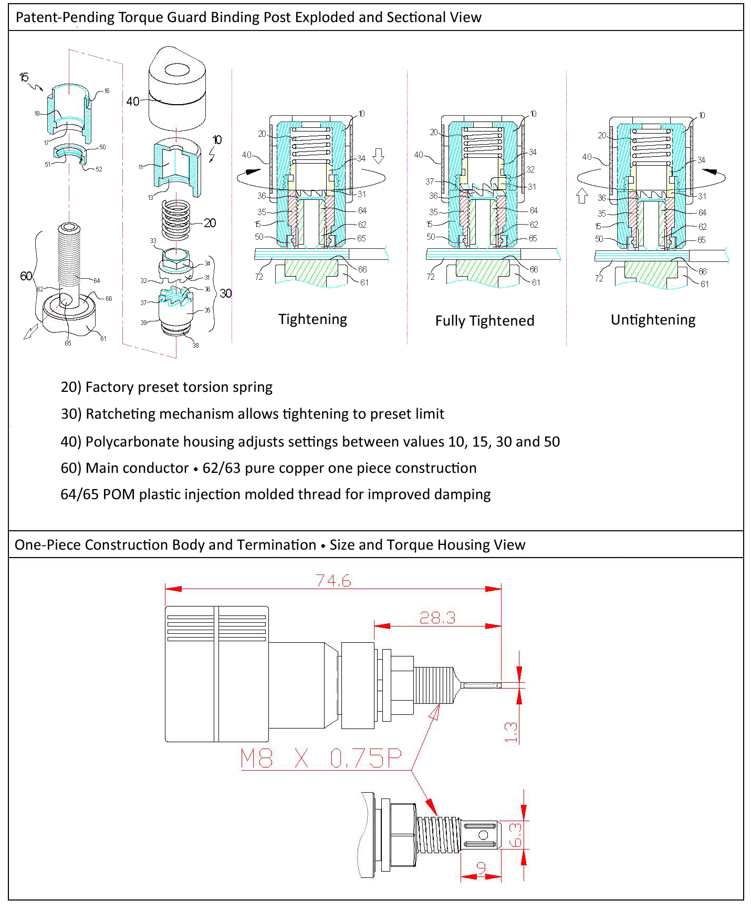
Make a More Powerful Connection with Furutech!
FURUTECH CO., LTD • service@furutech.com • www.furutech.com

