

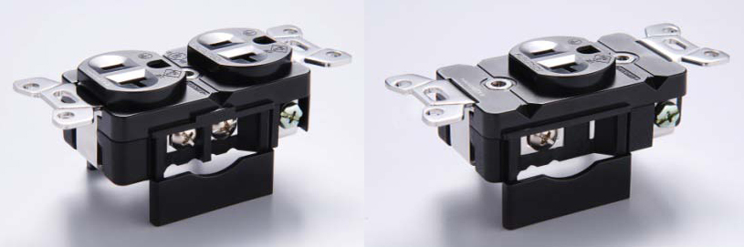

Furutech’s Top-Tier GTX Receptacles
Refinement has a New Name…

The Pure Transmission Mission
A very Furutech power product, manifesting a devotion to best performance in every element of AC and signal transfer Considering that what you actually hear is in a very real sense the direct product of the incoming AC then the final few feet are of prime importance for best performance.

Of course everyone would love to make pure-copper receptacles, but its malleability – lack of stiffness – makes pure copper a poor choice. That’s why you’ll find phosphor bronze or brass in some receptacles. Furutech’s intense engineering scrutiny has resulted in an industry-first, a technique allowing us to use special Furutech 24k gold- or rhodium-plated α (Alpha) pure copper conductors strengthened and sprung by our innovative nonmagnetic Stainless Steel Conductor Spring System that keeps a firm grip yet won’t damage male connector blades or their plated surfaces. Even the screw-down pressure plates are curved to maximize contact area. The GTX receptacle can be summed up in a word; virtuoso!

Features
- Rhodium or gold-plated α (Alpha) Pure Copper Conductor (0.8mm)
- Nonmagnetic stainless conductor spring system
- Body material: Nylon/fiberglass with piezo ceramic and carbon damping material
- Cover material: Polycarbonate
- Parts set with nonmagnetic 2.0mm-thick stainless brace plate
- Specified for wire diameters of 4mm (set screw)
- Dimensions: 104.0 mm (L) x 47.2 mm (W) x 28.0 mm (H)
- Total attention to detail and build quality extends right down to a specially designed patent-pending conductor pressure plate (see below) that increases contact area
- Furutech spade terminal FP-209-10 recommended for 10 AWG wire

Feel, experience and communicate with music and sound!
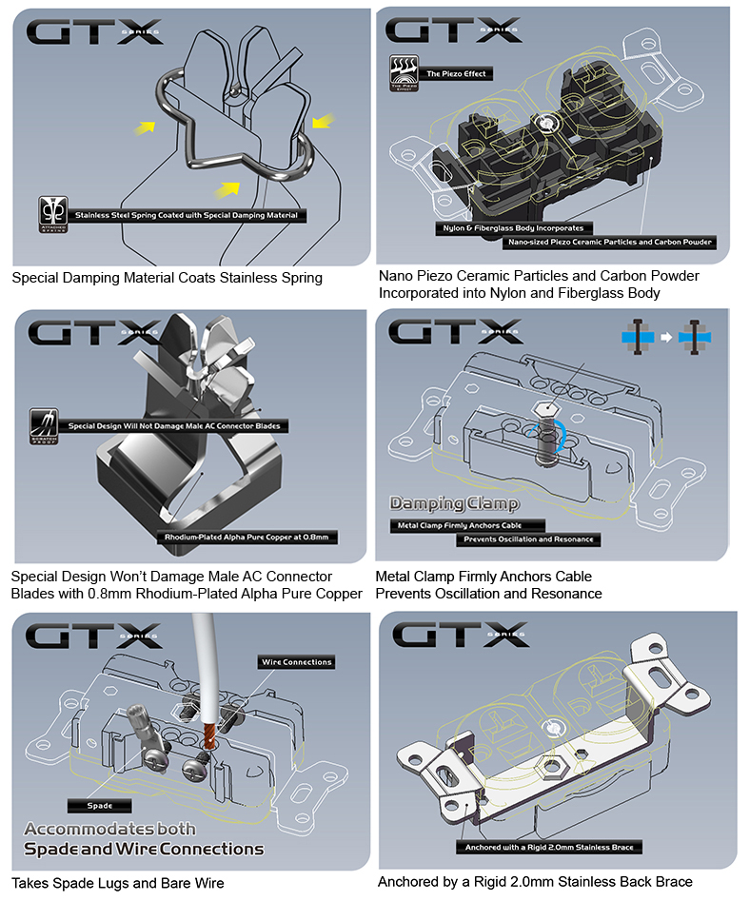
About Furutech
Furutech makes a wide variety of high performance 15A and 20A A/V cable and power connectors and parts, as well as distribution/filtering products including the 120Hz standard xv1.3 HDMI cable, GT2 USB 2.0 and GT3 USB 3.0 cables, Ag-12 Silver Tonearm Cable, The Silver Arrows Tonearm Cable, La Source Headshell Wires, Monza LP Stabilizer Weight, the new Lineflux and Evolution II series, Pure Power 6, e-TP4+4, e-TP609, e-TP615 and e-TP60 Power Distributors, and e-TP80 Power Filters, deMag Disc and Cable Demagnetizer, PC-2 Disc Pure Cleaner, and their own very special NANO Liquid Contact Enhancer, plus even more fine cable and OEM products.
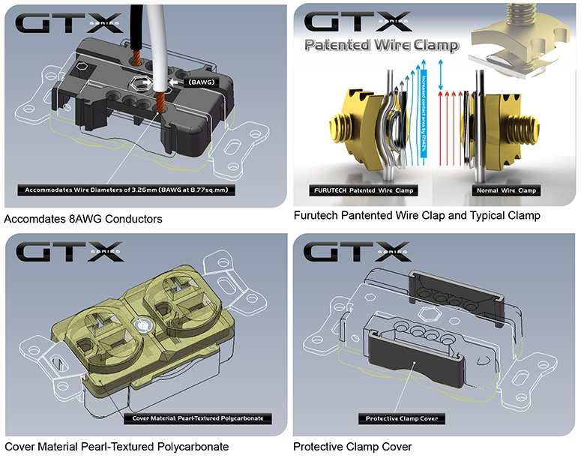
Awards
DeMag Wins CES Best of Innovations ’07 • e-TP609 Wins Absolute Sound Product of the Year Awards ’07 • G-302A-18 Power Cord Wins 6moons Blue Moon Award ’07 • Evolution Cables Wins Best of 2007 Awards Enjoy the Music • Reference III Cables Win Absolute Sound Editors’ Choice ‘07/’08 • AG-12 Phono Cable Wins the SoundStage Network’s Reviewers’ Choice Award ’08 • Ag-12 Phono Cable is Tone Audio’s Exceptional Value Award ’08 • Monza LP Stabilizer, Silver Arrows Phono Cable, La Source Headshell Extensions All Win Tone Audio’s Accessory Products of the Year • xv1.3 HDMI Cable Wins Positive Feedback’s Brutus Award ’08 • FI-50 Piezo Ceramic Series Connectors Win CES Best of Innovations ’09 • Monza LP Stabilizer Wins Positive Feedback’s Brutus Award ’09 • Select Series Fuses Win Positive Feedback’s Brutus Award ’09 • GT2 USB Cable is Playback Recommended ’09 • Torque Guard Speaker Binding Posts Innovations Honoree ‘10

Make A More Powerful Connection with Furutech!
FURUTECH CO., LTD • service@furutech.com • www.furutech.com

Info • Press • Photos • Reviews
Jonathan Scull • Scull Communications • 212 807.0519
jscull@scullcommunications.com • www.scullcommunications.com
Images and press releases • www.scullcommunications.com/pressresources.html

