

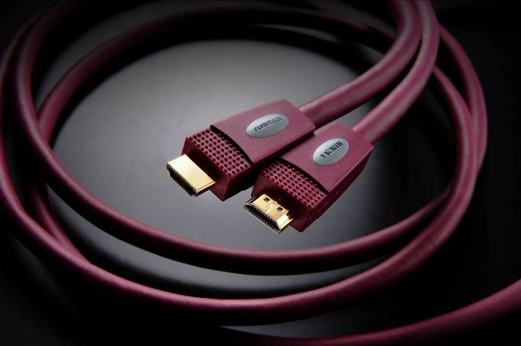
New at CES for 2011
HDMI-N1-4 HDMI Cable

Exceeds High Speed with Ethernet Specifications, 1080p-2160p, 12-bit Deep Color, 3D, 120/240Hz Refresh Rates

Tokyo, Japan • January 1st, 2010 • Furutech Co., Ltd., manufacturer of analog and digital audio and video cable plus a wide range of accessories, debuts HDMI-N1-4 HDMI cable. It exceeds new High Speed with Ethernet specifications with 1080p-2160p, 12-bit Deep Color, 3D, 120/240Hz refresh rates.

Everything Matters
There is a popular misconception that inexpensive HDMI cables perform as well as more costly designs and that digits are just digits. They said the same about SPDIF digital cables, but it’s generally accepted now that they do, and in fact the length of the cable matter to best avoid internal reflections that cause timing errors. The design, materials and build quality of every cable counts, especially with HDMI having to cope with greater and greater bandwidth. Meticulous attention to build quality is a large part of the Pure Transmission engineering equation: Top quality silver-plated μ–OFC conductors are surrounded by triple-layer shielding and terminated with Furutech’s beautifully-finished nonmagnetic α (Alpha) 24k gold-plated conductor in a 24k gold-plated nonmagnetic copper alloy body.

Features:
- Main conductors: Nonmagnetic α (Alpha) silver-plated μ–OFC for minimal transmission loss
- HDMI connector: Nonmagnetic 24k gold-plated α (Alpha) conductor with 24k gold-plated nonmagnetic copper alloy body
- Jacket: RoHS-compliant flexible PVC
- Triple shielding assures superior noise isolation
- Available in 1.2m/2.5m/5m/8m/10m/12m/15m/20m lengths

Make A More Powerful Connection with Furutech!

Construction and Materials
7-strand, 0.127 dia. α (Alpha) μ–OFC
1-strand 0.525 dia. α (Alpha) Silver plated μ–OFC
Skin-Foam-Skin PE OD dia. 1.37 ± 0.05mm
7-strand 0.127 dia. α (Alpha) μ–OFC
HDPE OD dia. 0.7 ± 0.05mm
Aluminum foil
Aluminum foil
24 x 10 0.10 dia. α (Alpha) μ–OFC braids
UL CL3 grade Flexible PVC

About Furutech
Furutech makes a wide variety of high performance 15A and 20A A/V cable and power connectors and parts, as well as distribution/filtering products including the 120Hz standard xv1.3 HDMI cable, GT2 USB 2.0 and GT3 USB 3.0 cables, Ag-12 Silver Tonearm Cable, The Silver Arrows Tonearm Cable, La Source Headshell Wires, Monza LP Stabilizer Weight, the new Lineflux and Evolution II series, Pure Power 6, e-TP4+4, e-TP609, e-TP615 and e-TP60 Power Distributors, and e-TP80 Power Filters, deMag Disc and Cable Demagnetizer, PC-2 Disc Pure Cleaner, and their own very special NANO Liquid Contact Enhancer, plus even more fine cable and OEM products.

Awards
DeMag Wins CES Best of Innovations ’07 • e-TP609 Wins Absolute Sound Product of the Year Awards ’07 • G-302A-18 Power Cord Wins 6moons Blue Moon Award ’07 • Evolution Cables Wins Best of 2007 Awards Enjoy the Music • Reference III Cables Win Absolute Sound Editors’ Choice ‘07/’08 • AG-12 Phono Cable Wins the SoundStage Network’s Reviewers’ Choice Award ’08 • Ag-12 Phono Cable is Tone Audio’s Exceptional Value Award ’08 • Monza LP Stabilizer, Silver Arrows Phono Cable, La Source Headshell Extensions All Win Tone Audio’s Accessory Products of the Year • xv1.3 HDMI Cable Wins Positive Feedback’s Brutus Award ’08 • FI-50 Piezo Ceramic Series Connectors Win CES Best of Innovations ’09 • Monza LP Stabilizer Wins Positive Feedback’s Brutus Award ’09 • Select Series Fuses Win Positive Feedback’s Brutus Award ’09 • GT2 USB Cable is Playback Recommended ’09 • Torque Guard Speaker Binding Posts Innovations Honoree ‘10

All Metal Parts Treated with Furutech’s α (Alpha) Super Cryogenic and Demagnetizing Process

FURUTECH CO., LTD. • service@furutech.com

Press • Info • Review • Images
Scull Communications • 212.807.0519
jscull@scullcommunications.com • www.scullcommunications.com
www.scullcommunications.com/pressresources.html

