

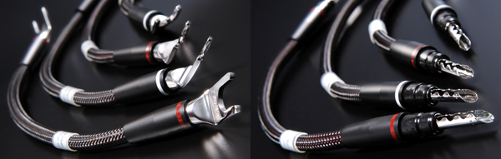

Furutech Speakerflux Jumper Cables
Don’t Contrain Your System at the Speaker Terminals
FP201R Spade Connectors or FB200BR Bananas

Furutech Co., Ltd., manufacturer of ultra refined analog, digital, video cable and accessories, debuts their top-of-the-line Speakerflux Jumper Cables, terminated with high-quality bananas plugs or spade lugs. The Flux series are, by far, the most revealing cable Furutech has ever made, designed to work best in an all-Flux systems including Lineflux, Speakerflux, Powerflux AC cords along with the Flux-50 Inline AC Filter and Daytona 303 for active and passive AC filtering and power distribution.

Everything Matters

Most enthusiasts know that everything in the signal path makes a difference, and that includes the jumpers used in biwired speakers system. Most jumper cables supplied by speaker manufacturers are adequate for the job, but Furutech has never subscribed to merely adequate. Furutech Speakerflux Jumper Cables use high-purity large diameter 6mm-squared α (Alpha) conductor for minimal internal impedance. Choose beautifully engineered FP-201R nonmagnetic pure-copper rhodium-plated spade connectors, or specify FP200BR nonmagnetic eutectic copper alloy rhodium-plated banana connectors. The Jumpers feature an insulation/dielectric of high-grade PE that reduces capacitance and resonance. The jacketing is RoHS-compliant PVC.

Construction and Materials

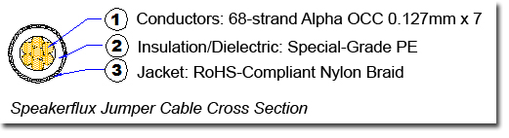

- 7 bundles x 68-strand α (Alpha) OCC conductor 0.127mm, 3.6mm total diameter
- Insulation: High-grade PE 5.3mm diameter
- Jacket: RoHS-compliant nylon braid approx. 6.2mm
- Connectors: FP201R spade terminals or FP-200BR banana connectors

α (Alpha) Conductors are comprised of fine OCC wires twisted around μ–conductor strands and treated with Furutech’s Alpha Cryogenic and Demagnetizing Process

Electrical Properties |  | Test Method
Max. Conductor Resistance | 3.0 Ω／km | JISC3005 6 20℃
Min. Insulation Resistance | 1000 MΩ-km | JISC3005 9.1 20℃
Dielectric Strength | AC. 1000 V／1 min. | JISC3005 8

Links

About Furutech

Furutech makes a wide variety of high performance 15A and 20A A/V cable and power connectors and parts, as well as distribution/filtering products including the 120Hz standard xv1.3 HDMI cable, GT2 USB 2.0 and GT3 USB 3.0 cables, Ag-12 Silver Tonearm Cable, The Silver Arrows Tonearm Cable, La Source Headshell Wires, Monza LP Stabilizer Weight, the new Lineflux and Evolution II series, Pure Power 6, e-TP4+4, e-TP609, e-TP615 and e-TP60 Power Distributors, and e-TP80 Power Filters, deMag Disc and Cable Demagnetizer, PC-2 Disc Pure Cleaner, and their own very special NANO Liquid Contact Enhancer, plus even more fine cable and OEM products.

Awards
DeMag Wins CES Best of Innovations ’07 • e-TP609 Wins Absolute Sound Product of the Year Awards ’07 • G-302A-18 Power Cord Wins 6moons Blue Moon Award ’07 • Evolution Cables Wins Best of 2007 Awards Enjoy the Music • Reference III Cables Win Absolute Sound Editors’ Choice ‘07/’08 • AG-12 Phono Cable Wins the SoundStage Network’s Reviewers’ Choice Award ’08 • Ag-12 Phono Cable is Tone Audio’s Exceptional Value Award ’08 • Monza LP Stabilizer, Silver Arrows Phono Cable, La Source Headshell Extensions All Win Tone Audio’s Accessory Products of the Year • xv1.3 HDMI Cable Wins Positive Feedback’s Brutus Award ’08 • FI-50 Piezo Ceramic Series Connectors Win CES Best of Innovations ’09 • Monza LP Stabilizer Wins Positive Feedback’s Brutus Award ’09 • Select Series Fuses Win Positive Feedback’s Brutus Award ’09 • GT2 USB Cable is Playback Recommended ’09 • Torque Guard Speaker Binding Posts Innovations Honoree ‘10

Make A More Powerful Connection with Furutech!

FURUTECH CO., LTD • service@furutech.com • www.furutech.com

Press • Info • Review • Images

Scull Communications • 212.807.0519

jscull@scullcommunications.com • www.scullcommunications.com

www.scullcommunications.com/pressresources.html

