
Positive Feedback’s May Sweepstakes…
Win One of Ten Copies of JRiver Media Center 18!

May 14th 2013 – We know, it’s almost too good to be true, Positive Feedback’s May sweepstakes: Win one of ten copies of JRiver Media Center 18, a $49.95 value!

What’s a JRiver? I use iTunes…
You won’t after hearing bit-perfect playback on CDs, HD audio (88.1 KHz, 176 KHz and above), DSD or any other audio signal to your DAC. JRiver is for the purist who wants what’s encoded on the media and nothing else.

JRiver Runs Deep
You can manipulate the sound and modify playback with upmixing, downmixing, bit-depth and speaker control. And as the audio path is fully 64-bit any adjustments to volume, bit depth and sample rate are mathematically lossless.

For best sound JRiver communicates directly with audio hardware without Windows or any other layer that resamples or processes the signal in any way. ASIO, WASAPI, and Kernel Streaming are all hardware direct, the soundcard is locked and you can’t play audio from a web browser or other program while JRiver is open.

JRiver is Well Stocked!
Audiophile companies using or recommending JRiver Media Center include Antelope Audio, Audio Research, Ayre, Benchmark, Digibit, MBL, NuForce, Scaena and PS Audio and Wavelength.

Other Salient Features

- Support for all lossless formats (FLAC, APE, ALAC, WM), AIFF and WAV files (including tagging)
- Bit-perfect playback (visualized with Audio Path)
- Industry leading DSD support (ASIO v2.2, DoP, SACD, DFF, DSF, etc.)
- DSP-rich environment (Room Correction, Bass Management, VST plug-in support, ReplayGain
- Memory playback

More Information
JRiver Website
JRiver Main Page on Wiki
JRiver Audiophile Information
JRiver Audio Output Modes

Featured at HDtracks.com

Enter the PFO Contest Here!

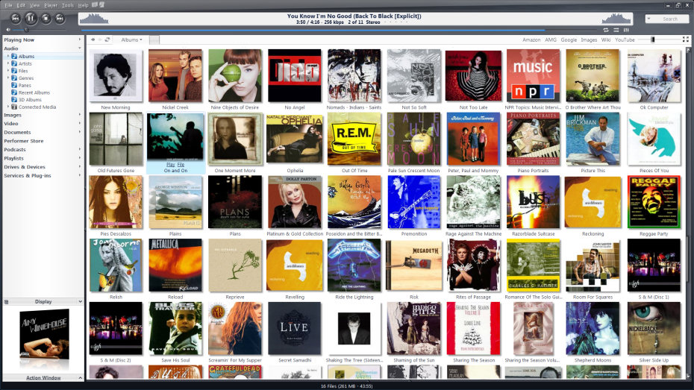

A familiar face… easy to use… powerful technology!

Enter the Positive Feedback Sweepstakes Today!

Visit Positive Feedback Exchange... an engaging community to buy, sell and discuss audio.

