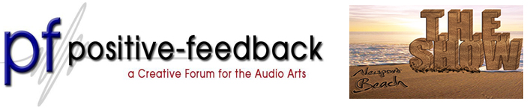

PFO Hospitality Suite Opens Its Doors Again for THE Show Newport Hilton Room 311
Audition DSD and Double-DSD ● Live Music ● Special Guest Stars ● June Give-Away Sweepstakes
Enlightening Drink, Good Cheer, Great Sound and Comfy Chairs ● Open All Day

May 28th 2013 – Positive Feedback Online and Positive Feedback Exchange will once again throw open the doors to their popular watering hole, the PFO Hospitality Suite at THE Show Newport Beach, Hilton room 311.

June’s Contest Give-Away a Mytek Stereo 192-DSD DAC
Enter to win a Mytek Stereo192-DSD Digital-to-Analog Converter, described as an ultra-transparent mastering-grade digital audio playback system. Using Sabre 32-bit conversion technology the DAC handles high-resolution PCM files up to 192kHz and DSD audio up to 128fs on USB 2.0, FireWire, AES/EBU, SPDIF, or TOSLINK. There’s even a USB 1.1 port available for driver-free connections for PCM audio up to 96kHz. Audition the Mytek in the PFO Hospitality Suite with new DSD-recordings mastered to LP (!) from MA Recordings on DSD and Double-DSD! Catch the DSD wave my friends…

No, No, I Love Music Not Equipment!
Well it’s true the real thing is hard to beat and so we’ve arranged a visit from a master guitarist and mandolinist of American finger-picking and blues styles Keith Knight! Plus an appearance by Don Alder, another master guitarist and harp guitarist from Canada. Both recording artists will have their CDs for sale so pull up to the bumper and buy a pair!

Special Guest Stars Mat Weisfeld of VPI Audio and Holger Stein of Germany’s Stein Music
Effervescent VPI Main Man Mat Weisfeld will be dropping in to share new product ideas and other VPI news… he’ll have pictures! Holger Stein of Stein Music brings his always fascinating system enhancements to our hospitality suite in room 311 of THE Show. Stop by and learn more about a man described as the Leonardo Da Vinci of audio!

The (Un)usual Suspects
The PFO in-room system includes a /Mytek Stereo 192 DSD DAC/VPI Traveler turntable with Grado cartridge/MacBook with Drobo NAS/Audirvana, Pure Music and Amarra software/Bel Canto C5i DAC Integrated Amplifier/Audience Au24e interconnects, speaker cables, powerChord e and extension, aR6-TS Power Conditioner and ClairAudient 1+1 speakers/PAD USB cables/Cardas, WyWires, Oyaide, Nordost and Furutech cables and a Nordost Qx2 Power Purifier.

Show Hours
Friday May 31 | 11:00am - 6:00pm
Saturday June 1 | 10:00am - 6:00pm
Sunday June 2 | 10:00am - 6:00pm

Visit Positive Feedback Exchange... an engaging community to buy, sell and discuss audio.

