Positive Feedback’s July Contest!
Win a Suite of XLO UltraPLUS Cables!

July 3rd 2013 – Positive Feedback Online announces their July sweepstakes, a suite of new cost-effective XLO UltraPLUS cables for classic XLO sound at surprisingly affordable prices.

A PLUS for Any System!
UltraPLUS cables are the latest, most advanced versions of the popular Ultra™ Series. They’re manufactured with classic XLO Field-Balanced Surface/Diving Winding Geometry™ so topologically the cable has no surface or center and frequency-related phase shift is canceled. Very low capacitance and inductance means XLO UltraPLUS cables work with a wide variety of components. The sound is clear and neutral with tight, powerful bass and an engaging midrange with clean and extended highs, hallmark XLO sound. UltraPLUS cables include single-ended and balanced interconnects, speaker cables, coaxial and AES/EBU digital and now USB. From half-meter lengths; 1m RCA single-ended $215.

Here’s What You Can Win!
One XLO UP10 6-ft AC Power Cord retail $300, one UP4U 2m USB digital datalink retail $175, one pair of UP1A 2m single-ended interconnect retail $280, one pair of UP2A 2m balanced Interconnect retail $325, one AES/EBU digital cable retail $180, and one pair of U6 8-ft speaker cables retail $370!

Now Featuring… UltraPLUS USB Cable
The quality of materials, design and configuration, build-quality and especially connector integrity – where many cheap USB cables fail over time – all grow in importance as sonic quality and resolution increases. Are we over-thinking USB Cables? You won’t think so once they’re installed! UltraPLUS USB cables are available in popular 1, 2 and 3m lengths; 1m $125.

And the Popular UltraPLUS AC Power Cords
Carrying its own patent this XLO Field-Balanced Surface/Diving Winding Geometry™ dual-gauge design optimizes power transfer and eliminates noise on the line above 60Hz. The revolutionary design features UP-OCC copper conductors with 12 AWG construction in a 2-way, multi-gauge winding geometry with individually insulated solid-core conductors in a counter-spiral lay for superior noise rejection. Double-shielded and double-grounded against EMI and RFI keeps sensitive source components isolated from line noise. Available with NEMA, Schuko, UK, AU or Swiss 15A or 20A IEC connectors from 3-ft lengths; 6-ft $300.

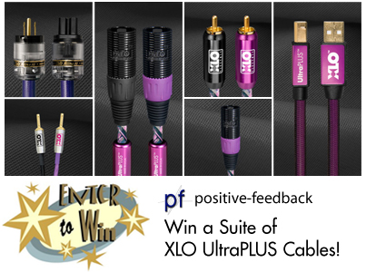

Click image to enter!

Visit Positive Feedback Exchange... an engaging community to buy, sell and discuss audio.

Hear More Deeply and Feel More Connected To Music Than Ever Before

XLO • 231 Bentley Street • Markham • Ontario • Canada L3R 3L1
Tel 905.479.2831 • Fax 905.479.9347 • http://www.xloelectric.com

