

Argentum Acoustics Cables
Engineering Truth
Elegant • Evocative • Existential!

"Music is the most perfect form of art."
- Albert Camus

Ontario, California • June 12th, 2008 • ULTRALINK/XLO PRODUCTS, INC., a manufacturer of premium audio/video cables and AC power products, announces a provocative new cable line called ARGENTUM ACOUSTICS®.

Allen Sung, President of Ultralink/XLO, enthuses, “Our sleek, elegant black and silver Argentum cables are ‘accumulated knowledge’ products, the best of all we’ve learned over more than ten years manufacturing cables, with engineering input from our own Roger Skoff, founder of XLO Electric.”

The attractive and beautifully-finished Argentum cables include the RCA/XLR MYTHOS™ interconnect, the MILLENIA™ AES/EBU digital datalink, the remarkable PROTEUS-12™ AC power cord, and the AUREUS-2™ speaker cable in single and biwire versions, all featuring lab-grade UPOCC copper conductors. The ARGENTO™ Digital, a high-frequency 75 Ohm coaxial cable, employs laboratory-grade silver conductors, and the complete line is available in popular lengths.

Enduring Quality
Argentum Acoustics® cables are manufactured with the very best materials, processes and dielectrics available, hand terminated with beautifully engineered, industrial designed connectors and an elegant black jacket. Conductors are 99.99997% laboratory-grade UPOCC (Ultra-Pure Ohno Continuous Cast) copper except for the silver Argento, and feature ultra-low capacitance DuPont™ Teflon™ insulation. Connectors are minimal mass and nonmagnetic ensuring low self-inductance and feature direct 24K gold-plated contacts. Speaker cables are terminated with interchangeable 8.0mm billet-cut spade lugs made from CDA alloy 101 (99.994% pure) copper and all are direct gold plated, with no intervening layer of nickel to spoil the sound. You can also choose quality Deltron-style banana plugs. All Argentum Acoustics® cables are cryogenically treated during the manufacturing process.

Being and Nothingness
In a nutshell, everyone says cables should be neutral and totally passive with zero effect on the sound. Argentum accepts that passing current through a conductor and its insulation (the dielectric) produces well-documented electrical phenomena, so we design our cables as the active components they really are. Current through a conductor and its insulator creates magnetic and electrostatic fields, plus the design must consider characteristic impedance, capacitance, resistance, inductive reactance, capacitive discharge effect, the dielectric constant and its dump rate. UHURead the packed-with-information white paper at http://argentumacoustics.com/multimedia/Argentum_Whitepaper.pdf.

Engineering Truth
Argentum follows the science, no off-world solutions, no magic, just solid engineering handsomely presented. Audio and video systems are immediately and appreciably better sounding, striking a high-value price/performance benchmark. Argentum Acoustics® cables are designed for high-end, two-channel systems and work extremely well in crossover video installations where sound is paramount.

Ultralink/XLO Products, Inc., based in Ontario, California, is an industry-leading manufacturer of high-performance audio and video cables, interconnects and AC power management and surge protection products. In early 2002, Ultralink acquired XLO Electric Company, Inc. an audiophile reference brand of high-end cables and related products. Ultralink/XLO Products, Inc. is a member of PARA, CEDIA and the CEA.

MSRP: $300 to $1000 • Available: Now
Argentum Acoustics • 909.947.6960 • HUwww.argentumacoustics.comU
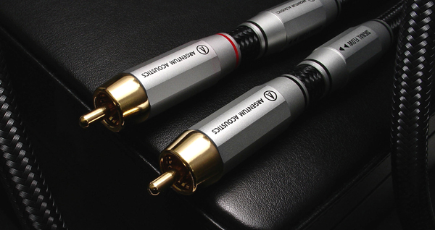

Info • Press • Photos • Reviews
Argentum and XLO
Jonathan Scull • Scull Communications 212 807.0519
HUjscull@scullcommunications.comU
HUwww.scullcommunications.comU

