

Dave Donald Joins the Up Group as VP Sales and Marketing
March 8th, 2011 • Ontario, California • Up Group/Ultralink Products is pleased to announce the addition of Dave Donald to their team as V.P. of Sales and Marketing. Dave is an industry veteran who most recently spent nine years as the V.P. of Marketing for SpeakerCraft.
“We are excited to have Dave join us and we are looking forward to working together,” said Allen Sung, Ultralink’s CEO. “He has the enthusiasm, drive and experience to energize our sales team, our reps and our dealers.”
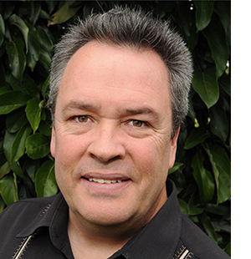
Mr. Donald will be based out of the company’s Southern California office and will be overseeing the company’s global sales and marketing efforts. “This is a great opportunity and I am looking forward to the challenge,” said Donald. “Allen and his team have created a very impressive product offering and I am going to take great pleasure in showing dealers how partnering with Ultralink can dramatically improve system performance and profitability.”


Dave Donald • V.P. Sales and Marketing
Tel: 909.947.6960 • Fax: 909.947.6970 • Cell: 909.767.2755
E-mail: david@ultralinkproducts.com

Info • Press • Photos • Reviews
Jonathan Scull • Scull Communications • 212 807.0519
jscull@scullcommunications.com • www.scullcommunications.com
Images and press releases • www.scullcommunications.com/pressresources.html

