

UltraLink/XLO Introduces MicroFlat HDMI and Caliber Series Cables at CES
And the Diminutive 5-Inch Square USub for UCubes and Other A/V Systems

Markham, Ontario, Canada • UltraLink/XLO Products, an innovative manufacturer of award-winning audio and video interconnects, cables, power products, speakers and personal audio accessories introduced the diminutive USub™ for UCubes™ or other audio/video 2.1 systems, MicroFlat™ HDMI® and a full line of Caliber™ Series cables at CES.


Respect the Power™
Introducing USub™ The World’s Smallest Powered Subwoofer
Add powerful bass to UCubes™ or any other speakers with the diminutive 5” square USub. Filling in the bass changes everything… video and music really pop! Everyone wants better sound, and with 95dB of room-filling power the USub™ delivers. It packs a big punch for a compact, attractive, easy-to-place subwoofer. The USub features a top-mounted volume control and 165Hz or 115Hz low-pass filters for blending the bass with UCubes or your current speakers.
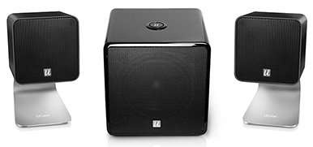
The USub is housed in a substantial yet sleek, space-saving high-gloss black-lacquer cabinet that that fits in anywhere. Once you have a USub you’ll probably want desktop speakers to match... like UCubes! Incredible sound in a small package, UCube speakers on their included brushed aluminum stands fill the listening space with vibrant sound. While the USub has an amazing effect on UCubes they can be used with all compact speaker systems bringing astounding bass to desktop, laptop, audio and 2.1 home theater systems for greater impact and dynamics with music, video and gameplay. $199.99 for the USub and $349.99 for a UCube/USub combo 2.1 system.

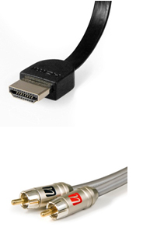
Everyone at CES was buzzing about UltraLink’s MicroFlat slimmer-than-slim HDMI cable with small yet robust connectors. MicroFlat delivers amazing flexibility creating cleaner, less obtrusive, easier to complete installations, and at the very same affordable prices as current UltraFlat cables! It’s an obvious class winner and available in popular 1, 2 and 3m lengths, 1m $30.

The Caliber series is finely-engineered and constructed for a mid-level line and outperforms competitive brands costing much more offering amazing performance for the price. It’s a natural fit for any home theater system especially when long-lasting quality and performance count. Stunning video coupled with open, detailed audio featuring wide, deep imaging and concussive bass slam make Caliber a worthy addition to any home entertainment system. Starting at half-meter, 1m $40.

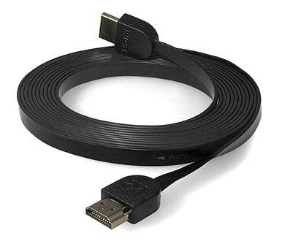

MicroFlat is also available in longer lengths



Meetings morning ‘til night at CES, left UltraLink’s Allen Sung flanked by Barry Ogg – the tall gentleman in a tie on the right -- and Kurt Miller somewhat more casual to the left, Allen striking a fine balance between them.

UltraLink Products Canada • 231 Bentley Street • Markham • Ontario • Canada L3R 3L1
Tel 905.479.2831 • Fax 905.479.9347 • Email cdnsales@ultralinkproducts.com • www.ultralinkproducts.com

