
Ultralink/XLO • Your HDMI Solutions Company at CES

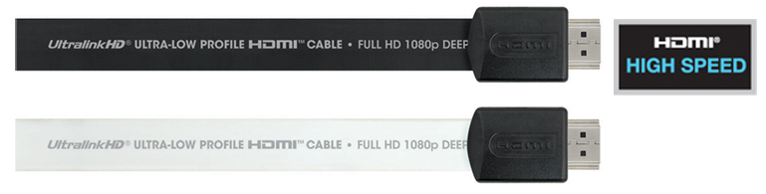
Ontario, California • January 6th, 2010 • Ultralink/XLO Products, Inc., an innovative and prolific manufacturer of award-winning audio and video interconnects, cables and AC power products, unveils a number of new products carefully engineered for today’s “space at a premium” environments behind electronics or that ultra-thin flat screen ready for installation.
New • UFHDMI • Ultra Flat HDMI Cables
Our proprietary, patented design makes this the flattest HDMI cable you can find. Their ultra-short connectors are optimized for tight, low-profile installs. They feature 30 AWG OFHC copper conductors and low-capacitance gas-injected dielectric insulation, and meet the latest High Speed HDMI specifications. You can have them in Black or White in 1m, 2m, and 3m lengths. Included with each Ultra Flat HDMI cable is an adjustable Right Angle Strain Relief! UFHDMI is rated for 1080P, 12-bit Deep Color, and 3D.

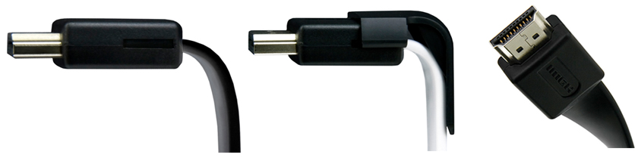
New • C2HDMI-RA • Challenger Series Right Angle HDMI Cables
Challenger Series Right Angle HDMI Cables meet and exceed new HDMI High Speed (for non-Ethernet) specifications. They feature 28 AWG 6N OFC copper conductors with full quad shielding -- 2 each of aluminum/Mylar foil and tinned copper braids. Not all HDMI cables are created alike! With its low-capacitance gas-injected dielectric insulation and a CL3/FT4-rated outer jacket the C2HDMI-RA is approved for all in-wall installations. The Challenger Right Angle can be had in convenient 1, 2, 3, 4, and 5m lengths with durable, precision-molded connectors and 24k gold-plated connections. It supports 1080P, 12-bit Deep Color, 3D, 4K, Dolby TruHD, HDMI-CEC, and 120HZ refresh rate.

Platinum MkII HDMI and Platinum MkII HDMI-XL
Reference quality cables with the look and feel of our perfectionist XLO™ and high-performance Argentum Acoustics® brands at a fraction of the price. They feature cryogenically-treated silver-plated Laboratory-Grade 6N copper conductors and quad-shielding. We use the best Teflon® dielectric insulation for the purest signal possible, along with precision-machined connectors manufactured to mil-spec tolerances with 24K direct gold-plated contacts. Platinum MkII is an “intelligent” cable with a connector chip that that removes corrupted HDCP and EDID data avoiding distortion products. The chip also enhances short- and long-run signal integrity. Platinum MkII is can be had in convenient lengths from 1 to 5m lengths, and Platinum MkII-XL from 30 to 75 foot lengths. Shorter runs of up to 5m of Platinum MkII deploy a nylon cable cover so they aren’t CL3/FT4-certified, but MkII-XL is certified for in-wall use. Platinum MkII supports 1080P, 12-bit Deep Color, 3D, 4K, Dolby TruHD, HDMI-CEC, and 120HZ refresh rate. Platinum MkII-XL also supports 30-bit Deep Color Depth.


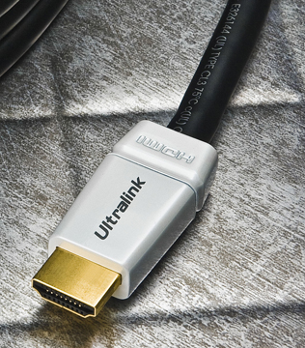

The Ethernet Connection
We all know it’s coming, and we’ll be showing Ethernet versions of Ultra Flat, Challenger Series Right Angle, and Platinum MkII and MkII-XL. Ethernet will integrate many new and exciting audio and video technologies and Ultralink/XLO is at the bleeding edge ready to provide solutions.


Ultralink/XLO Is Your HDMI And Cable Solutions Company!

How We Manage It
How does Ultralink offer so much performance at such ultra-value prices? Ultralink takes advantage of its economies of scale: Platinum II cables are easier to build than our Argentum and especially our XLO lines. They cost less to manufacture but are packed to the jacket with technology.

About XLO Products, Inc.
Ultralink/XLO Products Inc., headquartered in Ontario, California is an industry-leading manufacturer of high-performance audio and video cables and UltraPower™ AC power products, Canada's market share leader in the field. In early 2002 Ultralink Products Inc. acquired XLO Electric Co., Inc. a well-known brand of audiophile reference cables and interconnects. Ultralink also introduced the elegant “Engineering Truth” Argentum Acoustics™ line of cables and accessories. Ultralink is a member of PARA, CEDIA and the CEA. For more information on Ultralink/XLO and their product brands call (909) 947-6960 or find them at www.ultralinkproducts.com or learn more about XLO at www.xloelectric.com and Argentum Acoustics at www.argentumacoustics.com.

ULTRALINK/XLO PRODUCTS, INC. 1951 South Lynx Avenue Ontario, California, U.S.A. 91761 Tel: (909) 947-6960 Fax: (909) 947-6970 Web: www.ultralinkproducts.com

Info • Press • Images • Reviews
Jonathan Scull • Scull Communications • 212 807.0519
jscull@scullcommunications.com • www.scullcommunications.com www.scullcommunications.com/pressresources.html

