

UltraLink/XLO Introduces MicroFlat HDMI

Markham, Ontario, Canada • UltraLink/XLO Products, an innovative manufacturer of award-winning audio and video interconnects, cables, power products, speakers and personal audio accessories introduces MicroFlat™ HDMI®.

Ultimate Convenience and Performance
UltraLink’s MicroFlat™ slimmer-than-slim HDMI cables are discrete, easy to place and feature low-profile connectors ideal for tight spaces and behind-the-rack installations. MicroFlat offers amazing, long-lasting performance for the price with superb materials and construction. MicroFlat delivers stunning video, open, detailed and engaging sound in a wide, deep soundstage with concussive bass. Remarkably MicroFlat is no more expensive than UltraLink’s already affordable UltraFlat™ HDMI cable!

Specifications

- High Speed HDMI with Ethernet
- Supports full 1080p+ 12-bit deep color 3D 4K and all refresh rates
- High-purity copper conductors
- c(UL) listed high-stability PVC outer jacket

MSRP: $30, $40 and $50 for 1m, 2m and 3m lengths

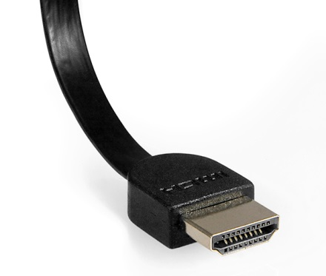
MicroFlat will also available in longer lengths

UltraLink Products Canada • 231 Bentley Street • Markham • Ontario • Canada L3R 3L1
Tel 905.479.2831 • Fax 905.479.9347 • Email cdnsales@ultralinkproducts.com • www.ultralinkproducts.com

