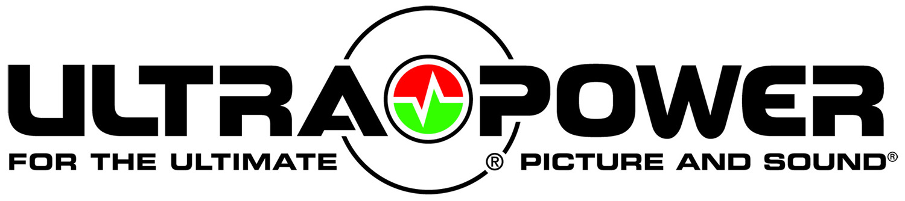
Ultralink/XLO Products, Inc.
1951 South Lynx Avenue
Tel: (909) 9476960 Fax: (909)947-6970
Web: www.ultralinkproducts.com
It’s All About Integration at Ultralink

Ontario, California • Ultralink/XLO Products, Inc., an innovative and prolific manufacturer of award-winning audio and video interconnects, cables and AC power products, unveils two exciting new power products. The POWERGRID® PGX-UPS IP Addressable Power conditioner with UPS battery backup and the POWERGRID PGX-7500 Home Theater AC Power Conditioner.

POWERGRID PGX-UPS IP Addressable Power Conditioner with UPS Battery Backup
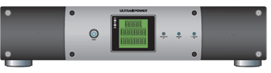

The PGX-UPS is an amazing voltage control and device that’s efficiently designed around its battery backup function. Most backup units trip only when there’s a power outage, but that leaves you completely unprotected against the constant power sags and surges that can wreak havoc on your valuable home theater components. The PGX-UPS maintains smooth, consistent power to your system with AVR (Automatic Voltage Regulation) technology that constantly correct for small voltage fluctuation creating a stable, clean power platform for all connected components. If the power goes out, the unit goes to battery power THEN switches to the AC line when power is restored. The 1200/640 watt battery provides up to 40 minutes of backup power ensuring system memory settings remain active. The PGX-UPS offers 10 surge-protected outlets (six with battery backup), 3 pairs of coax line protection, and installers take note, a USB port for IP address monitoring of the device. The PGX-UPS carries a 3-Year Warranty, a $500,000 Connected Equipment Warranty, and comes with a six foot premium power cord.

POWERGRID PGX-7500 Home Theater AC Power Conditioner
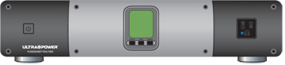

Another POWERGRID winner featuring protection, power conditioning, filtration, and optimization for all connected home theater components. It filters dangerous noise and other interference that affects everything you see and hear. The PGX-7500 has a full 13 programmable outlets including an ultra-convenient front-mounted auxiliary outlet. Six isolated filters provide Advanced Clean Power Filtration Circuitry™ to protect your valuable home theater components. The LCD display shows input voltage and output current on each bank of outlets! The patented ASP™ Microprocessor auto-disconnects when input voltage lurches to a dangerous level and restores power when safe levels return. The PGX-7500 is rated at 7560 Joules of energy storage with our effective and patented X3™ MOV protection circuit. Like the PGX-UPS it carries a 3-Year Warranty, a $500,000 Connected Equipment Warranty, and a six foot premium power cord.

Why You Need It
The unhappy fact of the matter is that you share your AC outlets with everyone on your utility transformer. Your outlets may look innocent, but there’s a raging storm behind them. For example the guy next door with a full metal shop and big lathes that draws down the power while sending huge spikes through the line. A little too dramatic you think? Look around; your A/C hums along in the summer, and your desk is probably littered with half-a-dozen chargers for your cell phone, GPS, and other Essential Devices you can’t get along without. Each of them nibbles voraciously at the AC exclusively at the top and bottom of the alternating 60Hz waveform causing a rippling effect that in turn causes distortion.

UltraPower Products Protect Your Investment
Our new power products offer battery backup with microprocessor-controlled voltage regulation plus power conditioning, filtration, and optimization for all connected home theater components. Ultralink provides system and integration solutions!

About Ultralink.
Ultralink/XLO Products Inc., headquartered in Ontario, California is an industry-leading manufacturer of high-performance audio and video cables and UltraPower™ AC power products, Canada's market share leader in the field. In early 2002 Ultralink Products Inc. acquired XLO Electric Co., Inc. a well-known brand of audiophile reference cables and interconnects. Ultralink also introduced the elegant “Engineering Truth” Argentum Acoustics™ line of cables and accessories. Ultralink is a member of PARA, CEDIA and the CEA. For more information on Ultralink/XLO and their product brands call (909) 947-6960 or find them at www.ultralinkproducts.com or learn more about XLO at www.xloelectric.com and Argentum Acoustics at www.argentumacoustics.com.

ULTRALINK/XLO PRODUCTS, INC. 1951 South Lynx Avenue Ontario, California, U.S.A. 91761 Tel: (909) 947-6960 Fax: (909) 947-6970 Web: www.ultralinkproducts.com

Info • Press • Images • Reviews
Jonathan Scull • Scull Communications • 212 807.0519
jscull@scullcommunications.com • www.scullcommunications.com www.scullcommunications.com/pressresources.html

