

It’s Been 21 Years… XLO Is Old Enough to Vote!
And We Nominate the New, Affordable UltraPLUS™ Line of Cables!

Markham, Ontario, Canada ● UltraLink/XLO Products, an innovative and prolific manufacturer of award-winning audio and video interconnects, cables, power products and accessories is 21-years-old! Through thick and thin, rain and sleet, snow and hail, XLO still brings you quality, innovative cable products and accessories. Like the new, surprisingly cost-effective UltraPLUS cable line.

Looks Like XLO… Wound Like XLO… But Can It Sing?
New UltraPLUS cables are updated replacements for the original and popular Ultra™ Series and actually modeled on the popular Reference™ series using XLO’s hum-bucking Field Balanced™ “exoskeleton” winding geometry with all-PTFE dielectrics, core structures and jacketing.

UltraPLUS incorporates many of the innovations and technologies that made XLO famous, a new benchmark in quality, affordable, high-performance cables. Rather than six-nines copper UltraPLUS is composed of single-filament, solid-core PC-OCC – Pure Copper Ohno Continuous Cast wire –wrapped in an sleek black and purple jacket. XLO significantly improved the already low self-inductance of the hand-terminated 24k direct gold-plated RCA and proprietary XLR connectors. You’ll hear more deeply and feel more connected to music than ever before! And everyone will appreciate their competitive pricing.

Surface/Diving Geometry
Pick up an XLO UltraPLUS cable and peer closely at its winding geometry. The Integrated Field-Balanced™ Surface/Diving winding techniques minimizes frequency-related phase-shift by reducing the thickness of each conductor grouping plus the diameter of each individual wire within the bundle to no more than twice the penetration depth – the depth within a wire that signal passes. In this way all frequencies pass through the entire thickness of the wire avoiding the dreaded signal-layer stratification effect.

Also notice what XLO calls the controlled “quasi-random” surface/diving winding of each wire bundle. It ensures no wire has what can be called a “normal” position within the grouping thus avoiding any “normal” phase-shift characteristics. Topologically speaking the cable has no surface or center and so frequency-related phase shift is effectively canceled allowing XLO cables to work better with a greater number of components. Yes, it IS brilliant!

UltraPLUS cables include Single-Ended and Balanced interconnects, Speaker cables, a Phono cable (available late Q1 2012), Coaxial Digital, AES/EBU Digital, Prices start at $150 for a half-meter single-ended interconnect.

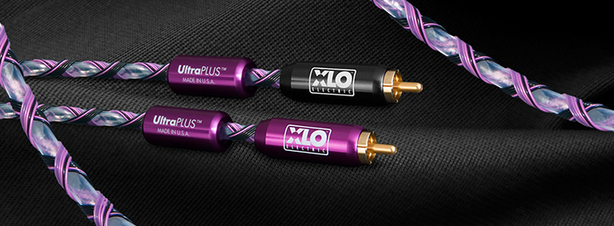

UltraLink Products Canada • 231 Bentley Street • Markham • Ontario • Canada L3R 3L1
Tel 905.479.2831 • Fax 905.479.9347 • Email cdnsales@ultralinkproducts.com • www.ultralinkproducts.com

