ULTRALINK/XLO PRODUCTS, INC.
1951 South Lynx Avenue
Ontario, California, U.S.A. 91761
Tel: (909) 947-6960 Fax: (909) 947-6970
Web: www.ultralinkproducts.com


For Immediate Release

Ultralink Unveils The First in Our Updated Series
Platinum MkII HDMI-XL

Ontario, California • 9/1/2009 • Ultralink/XLO Products, Inc., an innovative and prolific manufacturer of award-winning audio and video interconnects, cables and AC power products, pulls the covers off the new ultra long Platinum MkII HDMI-XL cable beginning at 30-foot lengths up to a neck-stretching 75 feet!

The extraordinary MkII HDMI-XL offers fantastic value and a ton of performance when running long lengths of HDMI. Most everyone wants better sound once they’ve heard it, but they don’t quite understand the high associated prices. Ultralink® Platinum MkII® solves the dilemma: Impressive audio and video with affordable over-engineered reference quality cables carrying the look and feel of our perfectionist XLO™ and high-performance Argentum Acoustics® brands at a fraction of the price!

Every Ultralink Platinum MkII-XL features cryogenically-treated silver-plated Laboratory-Grade 6N (99.99998% pure) copper and quad-shielding. We use the best dielectric insulation materials including DuPont™ Teflon® and Teflon polymers for the purest signal possible. Our connectors are precision-machined and manufactured to mil-spec tolerances with advanced metallurgy, 24K direct gold-plating to the conductor, and pure Teflon internal dielectrics. Our revolutionary and patented Vacuum Spring-Lock® RCA connector is the industry's leading "air-tight" design featuring greatly enhanced, 360-degree concentric contact surfaces and constant pressure.

How can Ultralink offer so much performance at such ultra value prices? Ultralink takes advantage of its economies of scale: Platinum II cables are more conventionally designed than our Argentum and especially our XLO lines. They’re easier to make, cost less to manufacture, and packed to the jacket with technology. You might say they’re impressively affordable! You might say that.

The First in a New Series
The Ultralink Platinum MkII HDMI-XL is just the first in our rollout of the updated, timely, cost-effective, ultra performance Platinum MkII series. Stay tuned for word on the rest of the line as it debuts!

Available: Now!

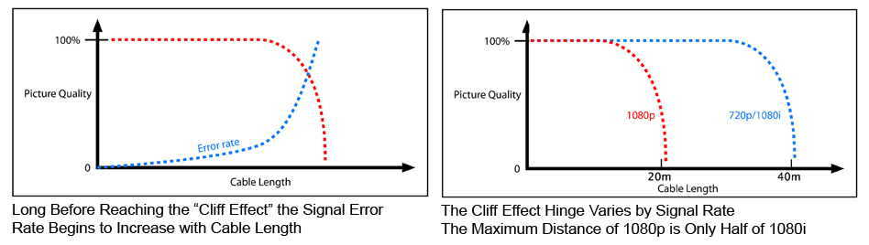
Platinum MkII HDMI-XL Cables
Lemmings, the Cliff Effect, and Your Digital Self
There exists a huge misconception that HDMI cables are all the same. Au contraire, as we say at Ultralink/XLO! In fact optimum performance is critical to HDMI as it’s the first technology to actually push the limits of high-speed digital transmission.

Analog signal picture quality gradually declines over longer cable lengths. Amplitude losses result in a dimmer image, high frequency signal loss in a “softer” image, and low frequency loss results in horizontal image smearing.

Digital video signals are quite different. As cable length increases the image quality remains the same until you hit a particular length—the cliff—after which the image disappears altogether. The illustration above left shows the Cliff Effect (in red) but also that error rates (in blue) actually climb as you approach the cliff. All The Good, The Bad and The Ugly HDMI cables pass adequate signal right up to the point where, like the fabled lemming, they fall off a steep cliff. Ultralink Platinum MkII draws you farther back from the edge of the cliff with its high specification performance.

As data errors climb error correction must work harder. At Ultralink we know the less error correction the better. The illustration above right shows how a low quality cable may work fine with current 1080i technology but not so well with 1080p signals coming Real Soon Now. Ultralink Platinum MkII draws you farther back from the edge of the cliff with its high specification performance.

Not to mention the more immediate problem of long runs of HDMI. Installers fitting a projector or video enthusiasts doing their own work appreciate that Platinum MkII HDMII-XL’s price pales in comparison to the cost of that high-performance projector or big HDTV in your living room!

About Ultralink Products, Inc.
Ultralink/XLO Products Inc., headquartered in Ontario, California is an industry-leading manufacturer of high-performance audio and video cables and UltraPower™ AC power products, Canada's market share leader in the field. In early 2002 Ultralink Products Inc. acquired XLO Electric Co., Inc. a well-known brand of audiophile reference cables and interconnects. Ultralink also introduced the elegant “Engineering Truth” Argentum Acoustics™ line of cables and accessories. Ultralink is a member of PARA, CEDIA and the CEA. For more information on Ultralink/XLO and their product brands call (909) 947-6960 or find them at www.ultralinkproducts.com or learn more about XLO at www.xloelectric.com and Argentum Acoustics at www.argentumacoustics.com.

Info • Press • Photos • Reviews • Argentum and XLO
Jonathan Scull • Scull Communications • 212 807.0519
jscull@scullcommunications.com • www.scullcommunications.com
www.scullcommunications.com/pressresources.html

