
Ontario, California • November 18, 2010 • Ultralink/XLO Products, Inc., an innovative and prolific manufacturer of award-winning audio and video interconnects, cables and AC power products introduces the UltraPower® PGX-UPS IP-addressable Surge Protector and battery backup.
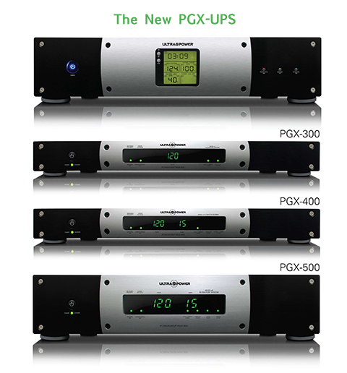
The PGX-UPS completes our line of UltraPower AC system control products. We have every product for every need, no gaps! The PGX-UPS is – remarkably – an IP-addressable battery backup and surge protector featuring AVR™ Automatic Voltage Control. Check and change settings on your computer!

The PGX-UPS is efficiently designed around its battery backup function. Most backup units trip only when there’s a power outage, but that leaves you completely unprotected against the constant power sags and surges that can wreak havoc on your valuable audio and home theater components. The PGX-UPS maintains smooth, consistent power to your system with AVR (Automatic Voltage Regulation) technology that constantly correct for small voltage fluctuation creating a stable, clean power platform for all connected components. If the power goes out, the unit goes to battery power then switches back to the AC line when power is restored. The 1200/640 watt battery provides up to 40 minutes of backup power ensuring system memory settings remain active.

The PGX-UPS features 10 surge-protected Outlet (6 with battery backup), the 1200VA/640W battery, a 5,500 Joule rating, 3 pairs of Coax Line Protection, 1 pair Data, and 1 pair Phone protection, and an IP-addressable USB port to monitor the UPS and change settings! It carries a 3-Year Warranty, a $500,000 Connected Equipment Warranty, and comes with a six foot premium power cord.

Reflecting UltraPower Style, the PGX-UPS has a handsome and informative front panel with an overall fit and finish that’s decidedly upscale. Like the rest of the line, the PGX-UPS appears elegant and non-intimidating making it easier to close the sale especially when appearance counts. Not just another pretty face in our line, each PGX-UPS is built to high standard specifications for top performance in every respect.

Ultralink has you covered!

ULTRALINK/XLO PRODUCTS, INC. 1951 South Lynx Avenue Ontario, California, U.S.A. 91761 Tel: (909) 947-6960 Fax: (909) 947-6970 Web: www.ultralinkproducts.com

Info • Press • Images • Reviews
Jonathan Scull • Scull Communications • 212 807.0519
jscull@scullcommunications.com • www.scullcommunications.com www.scullcommunications.com/pressresources.html

