

Tune In and Turn On as Ultralink Changes its Stripes!

Refreshed Brands and Logos • Quality • Versatility • Flexibility
Every Price Point • Every System Need

Ontario, California • 10/5/2010 • You know us and love us as Ultralink, but now we’ve positioned our powerful, refreshed brands under the Up Group® banner with a bold new logo. All UP Group product lines reflect our fundamental values, delivering top build quality, leading- edge engineering, production and performance. From the latest HDMI cables to full A/V cable and power solutions, for installers and consumers, UP Group’s individual brands ensure value, reliability, versatility and flexibility at every price point for every system need.

The map below gives an instant picture of the refreshed Up Group® hierarchy. Up Group sits at the top, next level is Argentum Acoustics®, UltraLink®, UltraPower®, and venerable XLO™. In the following level, UFi is a division of UltraLink, and UltraPower Planet Green™ flows from UltraPower
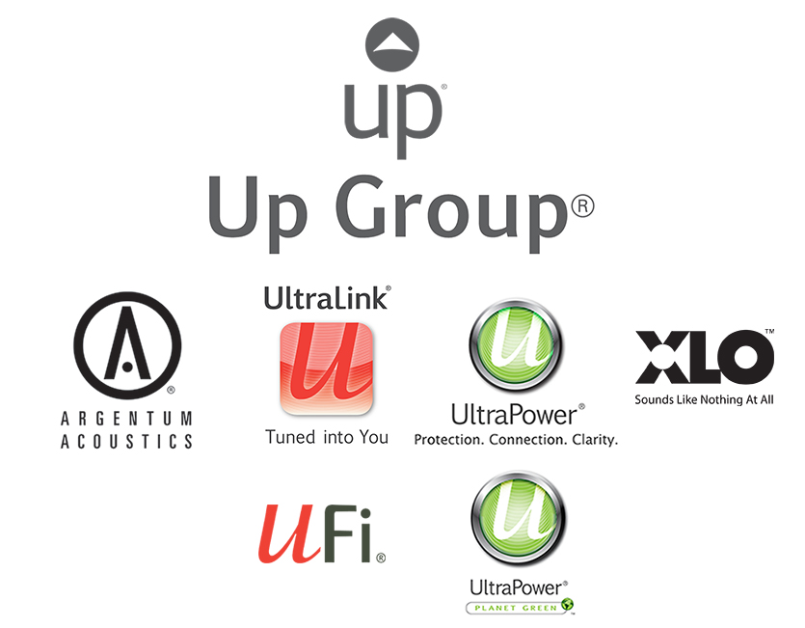

Ultralink Products • 1951 South Lynx Avenue Ontario, California, U.S.A. 91761
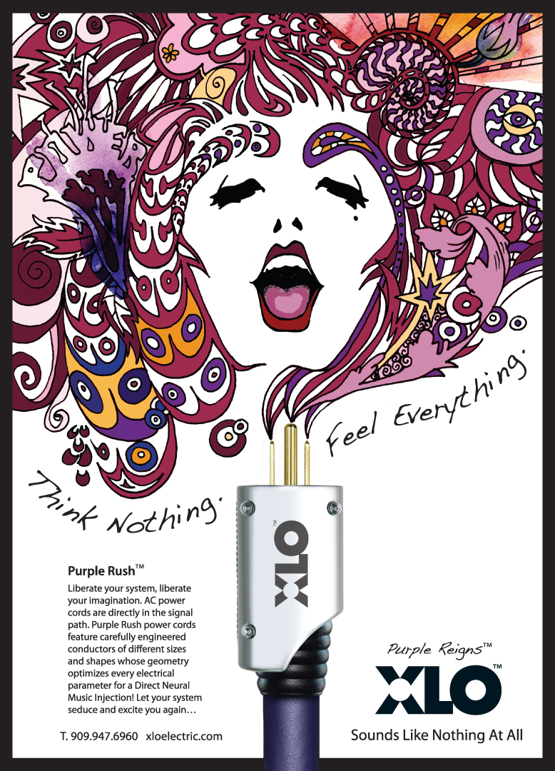
Tel: (909) 947-6960 Fax: (909) 947-6970 Web: www.ultralinkproducts.com

Info • Press • Images • Reviews • Jonathan Scull • Scull Communications
212 807.0519 • jscull@scullcommunications.com • www.scullcommunications.com www.scullcommunications.com/pressresources.html

