

UltraPower’s Planet Green Surge Protectors with USB Remote On/Off

Ultralink/XLO Products, Inc., an innovative and prolific manufacturer of award-winning audio and video interconnects, cables and AC power products introduces the UltraPower® Planet Green™ series Multimedia Surge Protectors. The PG-805 and PG-503 reveal our commitment to environmentally conscious engineering and feature a USB Remote On/Off controller making them ideal for enthusiasts and installers.

Save Energy, Save Money
Most power supplies for multimedia entertainment, computer-based systems and peripherals draw current even in standby mode, an obvious waste of resources. Our PG-805 and PG-503 feature a USB Remote On/Off Controller making it simple and convenient to completely turn off the power to its Energy Saving Outlets by simply pressing a button on the free-standing/wall-mount USB Remote, or automatically if the Remote is plugged into a USB port.

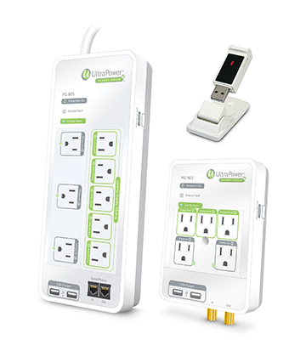
The PG805 features 3 Always On Outlets and 5 Energy Saving Outlets, a pair of USB charging ports and RJ11/RJ45 protection plus a high quality power cord. The PG-503 offers 2 Always On and 3 Energy Saving Outlets, a pair of USB charging ports, coaxial cable surge protection, and plugs directly into your outlets.

The PG series Surge Protectors also reduce noise with high frequency capacitors and a choke. Additionally, the robust AC surge protection saves your valuable components from surges and voltage spikes. We use the latest X3™ MOVs (Metal Oxide Varistors) made with improved materials and technology.

As well as freestanding you can plug the USB Remote into a component’s USB port. The Remote senses power-up or power-down on the USB port and sends a corresponding on or off signal to the five Energy Saving Outlets on one or more PG series Surge Protectors. Add additional Planet Green components and pair them with a single Remote for ultimate system control!

About Ultralink Products, Inc.
Ultralink/XLO Products Inc., headquartered in Ontario, California is an industry-leading manufacturer of high-performance audio and video cables and UltraPower® AC power products, Canada's market share leader in the field. In early 2002 Ultralink Products Inc. acquired XLO Electric Co., Inc. a well-known brand of audiophile reference cables and interconnects. Ultralink also introduced the elegant “Engineering Truth” Argentum Acoustics™ line of cables and accessories. Ultralink is a member of PARA, CEDIA and the CEA. For more information on Ultralink/XLO and their product brands call (909) 947-6960 or visit them at www.ultralinkproducts.com or learn more about XLO at www.xloelectric.com and Argentum Acoustics at www.argentumacoustics.com.

Up Group/Ultralink Products
231 Bentley Street • Markham • Ontario • Canada L3R 3L1
Tel 905.479.2831 • Fax 905.479.9347
Email cdnsales@ultralinkproducts.com
Web www.ultralinkproducts.com

Info • Press • Images • Reviews
Jonathan Scull • Scull Communications • 212 807.0519
jscull@scullcommunications.com • www.scullcommunications.com www.scullcommunications.com/pressresources.html

