

UltraLink Ships the 5-Inch Square USub for UCubes and Other A/V Systems

Markham, Ontario, Canada • UltraLink/XLO Products, an innovative manufacturer of award-winning audio and video interconnects, cables, power products, speakers and personal audio accessories introduces the USub™ for UCubes™ or other audio/video 2.1 system.


Respect the Power™
Introducing USub™ The World’s Smallest Powered Subwoofer
Add powerful bass to UCubes™ or any other speakers with the powerful UltraLink USub. Filling in the bass changes everything… video and music really pop! Everyone wants better sound, and with 95dB of room-filling power the USub delivers. It packs a big punch for a compact, attractive, easy-to-place subwoofer. The USub features a top-mounted volume control and 165Hz or 115Hz low-pass filters for blending the bass with UCubes or your current speakers.

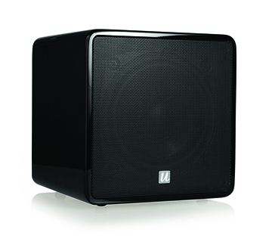
The USub is housed in a substantial yet sleek, space-saving 5-inch square high-gloss black-lacquer cabinet and the sound is totally stunning! Once you have a USub you’ll probably want desktop speakers to match... like UCubes! Incredible sound in a small package, UCube speakers on their included brushed aluminum stands fill the listening space with vibrant sound. While the USub has an amazing effect on UCubes they can be used with all compact speaker systems bringing astounding bass to desktop, laptop, audio and 2.1 home theater systems for greater impact and dynamics with music, video and gameplay. $199.99 for the USub and $349.99 for the UCube/USub combo 2.1 system.

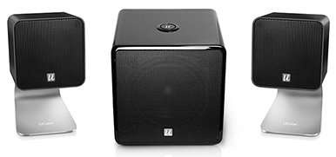
Pump up the bottom end with quality bass on a pair of UltraLink UCube™ USB speakers or any other 2.1 audio system. Respect the power! The review line starts here!

Features
- 4-inch high-excursion woofer
- 50W RMS – 100W peak amp
- Auto-Sensor On / Off 0.5W standby
- 165Hz or 115Hz low-pass filter
- Top-mounted volume control
- 46Hz – 165Hz frequency response
- Maximum SPL 95dB
- Compact 5" x 5" x 5" cabinet
Package Includes
- USub Multimedia Subwoofer
- 2-Meter audio cable
- 6-Ft. AC power cord
- Owner’s Manual
UltraLink Products • 231 Bentley Street • Markham • Ontario • Canada L3R 3L1
Tel 905.479.2831 • Fax 905.479.9347 • Email cdnsales@ultralinkproducts.com • www.ultralinkproducts.com

