

XLO Introduces New UltraPLUS Series Cables at CES 2013
The Latest Most Advanced Versions of the Popular Ultra™ Series

Markham, Ontario, Canada • UltraLink/XLO Products, an innovative manufacturer of award-winning audio and video interconnects, cables, power products, speakers and personal audio accessories announced introduce the new UltraPLUS line of cables, the latest and most advanced versions of the popular Ultra™ Series.

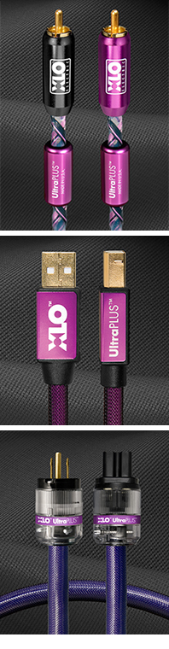
Introducing UltraPLUS
UltraPLUS cables are the latest, most advanced versions of the popular Ultra™ Series. They’re manufactured with classic XLO Field-Balanced Surface/Diving Winding Geometry™ so topologically the cable has no surface or center and frequency-related phase shift is canceled. Very low capacitance and inductance means XLO UltraPLUS cables work with a wide variety of components. The sound is clear and neutral with tight, powerful bass and an engaging midrange with clean and extended highs, hallmark XLO sound. UltraPLUS cables include single-ended and balanced interconnects, speaker cables, a phono cable, coaxial and AES/EBU digital. From half-meter lengths; 1m RCA single-ended $215.

UltraPLUS USB Cable
The quality of materials, design and configuration, build-quality and especially connector integrity – where many cheap USB cables fail over time – all grow in importance as sonic quality and resolution increases. Are we over-thinking USB Cables? You won’t think so once they’re installed! UltraPLUS USB cables are available in popular 1, 2 and 3m lengths; 1m $125.

UltraPLUS AC Power Cords
Carrying its own patent this XLO Field-Balanced Surface/Diving Winding Geometry™ dual-gauge design optimizes power transfer and eliminates noise on the line above 60Hz. The revolutionary design features UP-OCC copper conductors with 12 AWG construction in a 2-way, multi-gauge winding geometry with individually insulated solid-core conductors in a counter-spiral lay for superior noise rejection. Double-shielded and double-grounded against EMI and RFI keeps sensitive source components isolated from line noise. Available with NEMA, Schuko, UK, AU or Swiss 15A or 20A IEC connectors from 3-ft lengths; 6-ft $300.

The review line starts here!
Hear More Deeply And Feel More Connected To Music Than Ever Before
UltraLink/XLO • 231 Bentley Street • Markham • Ontario • Canada L3R 3L1
Tel 905.479.2831 • Fax 905.479.9347 • http://www.xloelectric.com

