

Purple Reigns™ Series Purple Rush™ Power Cord
The Most Accomplished Power Money Can buy

Ontario, California • 11/18/2010 • Ultralink/XLO Products, Inc., an innovative and prolific manufacturer of award-winning audio and video interconnects, cables and AC power products, unleashes the Purple Reigns™ Series Purple Rush™ Power Cord, the most accomplished power money can buy.

Its audacious low-noise, low-loss, high-speed design was awarded five separate patents! Purple Rush employs continuous cast/multi-gauge/multi-shaped conductors that overcome AC transmission line problems. Powerful monoblock amplifiers to front-end separates all achieve a breathtaking openness and transparency, lightning quick transients, simply incredible slam and palpable imaging with seductive warmth and richness.

Purple Construction Techniques
The Purple Rush power cord is packed with unique technologies. It’s constructed of 6 AWG PC-OCC copper in multiple gauges and shapes. Fine gauge PC-OCC conductors are used for the upper-bass around 60Hz; one massive solid flat PC-OCC conductor for the mid-bass; and multiple gauges of large-diameter, individually-insulated, solid-core PC-OCC conductors are bundled together for the lowest frequencies. That’s the power cord’s secret; it literally embodies the best of all possible worlds for every frequency resulting in a most accomplished sound. Click here for the Purple Rush White Paper.

Features
- All 6 AWG PC-OCC Ohno Continuous-Cast Monocrystal Pure Copper conductors
  - Fine-gauge conductors for the highs
  - Massive solid flat conductor for the midrange
  - Multiple gauges of large-diameter, individually-insulated, solid-core conductors bundled together for the bass
- Quad shielding of silver-clad copper braid
- Advanced cold-crimping and hot spot-welding construction techniques
- 24k gold-plated nonmagnetic solid-billet copper pins and blades
- Connectors machined from solid billet
- Removable ground pin
- Extreme low-noise, high-speed design awarded five separate patents
- Brings a new level of refined beauty, power, dynamics and spaciousness to high-performance systems

Benefits
- Extremely low noise
- Instant current availability
- No dynamic restriction
- Evenly distributed noise cancellation
- High surface area conductors
- Reduced long-grain copper boundaries
- Eliminates ground loops
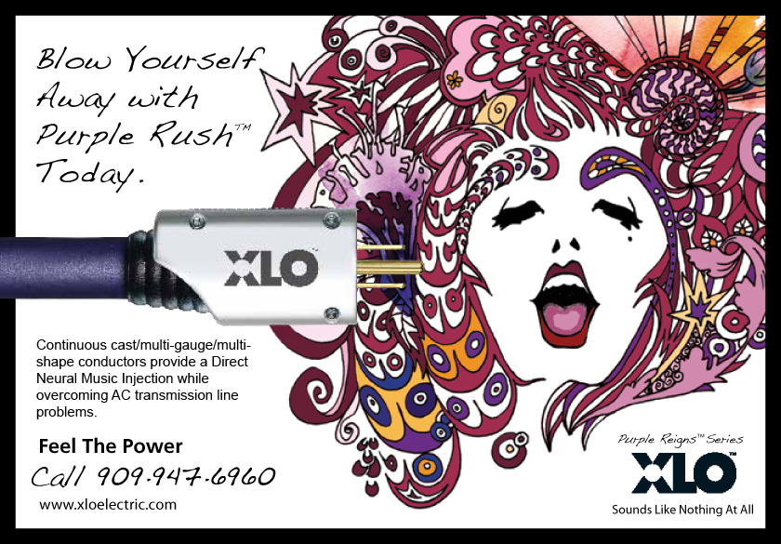

ULTRALINK/XLO PRODUCTS, INC. 1951 South Lynx Avenue Ontario, California, U.S.A. 91761 Tel: (909) 947-6960 Fax: (909) 947-6970 Web: www.xloelectric.com
Info • Press • Images • Reviews
Jonathan Scull • Scull Communications • 212 807.0519
jscull@scullcommunications.com • www.scullcommunications.com www.scullcommunications.com/pressresources.html

